A Review of Liver Patient Analysis Methods using Machine Learning

Introduction

Overview

The goal of this project is to reduce some of the delays caused by unnecessary detours between the hospital and the pathology laboratory. Historically, work has been done to detect the onset of heart disease, such as Parkinson`s, and machine learning algorithms have been developed to predict liver disease in patients based on variety of characteristics.

Liver disease averts the normal function of the liver. This disease caused by an assortment of elements that harm the liver. Diagnosis of liver infection at the preliminary stage is important for better treatment. In today`s scenario device like sensors are used for detection of infections. Accurate classification techniques are required for automatic identification of disease samples. This disease diagnosis very costly and complicated.

Purpose

The goal of this work is to evaluate the performance of different machine learning algorithms in order to reduce the high cost of liver disease diagnosis.

Early prediction of liver disease using classification is an algorithms is an efficacious task that can help the doctors to diagnose the disease within a short duration time. In this project we will analyse the parameters of various classification algorithms and compare their predictive accuracies so as to find out the best classifier for determining the liver disease. This project compare various classification algorithms such as Random Forest, Logistic Regression, KNN and ANN algorithms with an aim to identify the best technique. Based on this study, Random Forest with the highest accuracy outperformed the other algorithms and can be further utilized in the prediction of liver disease and can be recommended to the user.

**ADVANTAGES & DISADVANTAGES**

**ADVANTAGES**

* AUTOMATED HEALTH RECORD DIGITIZATION: Maintaining accurate and up-to-date medical records manually is downright tedious and exhausting. Technology has greatly eased the data entry process to make it faster, effortless, and more reliable.

* IMPROVED QUALITY AND SPEED OF DIAGNOSIS: There are a lot of life-threatening diseases that require early-stage detection. The combination of supervised and unsupervised algorithms in ML would certainly prove to be highly beneficial. Further, a comparison of historical data with the patient’s current health statistics would help identify the symptoms of a particular condition and even raise a red flag. This would prompt medical practitioners to take corrective action on time.
* STREAMLINING DIAGNOSTICS: Specialized areas of medicine involve the recognition of specific patterns such as pathology, radiology, and dermatology. These disciplines have witnessed increased adoption of ML models that are trained to scan medical images and identify abnormalities. This helps enhance the pace of diagnostic procedures with accuracy to achieve the ultimate goal of improving patient care.

While Machine Learning has a lot of untapped potential for the sector, it is not without challenges like heterogeneous data, inaccurate health records, disparate data systems & supportive software. Not to mention – there exist specific ethical concerns surrounding data security, confidentially, patient safety, and accountability, patient safety, and accountability. So, if you want to benefit from implementing ML in your organization, be sure to consult a healthcare IT specialist who can offer a solid blend of development experience and technical in building smart healthcare solutions.

DISADVANTAGES

* DATA ACQUISITION:

Machine Learning requires massive data sets to train on, and these should be inclusive/unbiased, and of good quality. There can also be times where they must wait for new data to be generated.

* TIME AND RESOURCES:

ML needs enough time to let the algorithms learn and develop enough to fulfill their purpose with a considerable amount of accuracy and relevancy. It also needs massive resources to function. This can mean additional requirements of computer power for you.

* INTERPRETATION OF RESULTS:

Another major challenge is the ability to accurately interpret results generated by the algorithms. You must also carefully choose the algorithms for your purpose.

* HIGH ERRO-SUSCEPTIBILITY:

Machine-Learning is autonomous but highly susceptible to errors. Suppose you train an algorithm with data sets small enough to not be inclusive . You end up with biased predictions coming from a biased training set. This leads to irrelevant advertisements being displayed to customers. In case of ML, such blunders can set off a chain of errors that can go undetected for long periods of time. When they do get noticed, it takes quite some time to recognize the source of the issue, and even longer to correct it.

APPLICATIONS

We are building a flask application which needs

HTML pages stored in the templates folder and a

Python script app.py for scripting.

ETC.pkl is our saved model. Further we will use this

Model for flask integration.

Training folder contains a model training file.

CONCLUSION:

Diseases related to liver and heart are becoming more and more common with time. With continuous technological advancements, these are only going to increase in the future. Although people are becoming more conscious of health nowadays, and are joining yoga classes, dance classes; still the sedentary lifestyle and luxuries that are continuously being introduced and enhanced; the problem is going to last long.

So, in such a scenario, our project will be extremely helpful to the society. With the dataset that we used for this project, we got 100% accuracy for SVM model, and though it might be difficult to get such accuracies with very large datasets, from this projects results, one can clearly conclude that we can predict the risk of liver diseases with accuracy of 90% or more.

FUTURE SCOPE

Today almost everybody above the age of 12 years has smartphones with them, and so we can incorporate these solutions into an android app or ios app. Also it can be incorporate into a website and these app and website will be highly beneficial for a large section of society.

RESULT

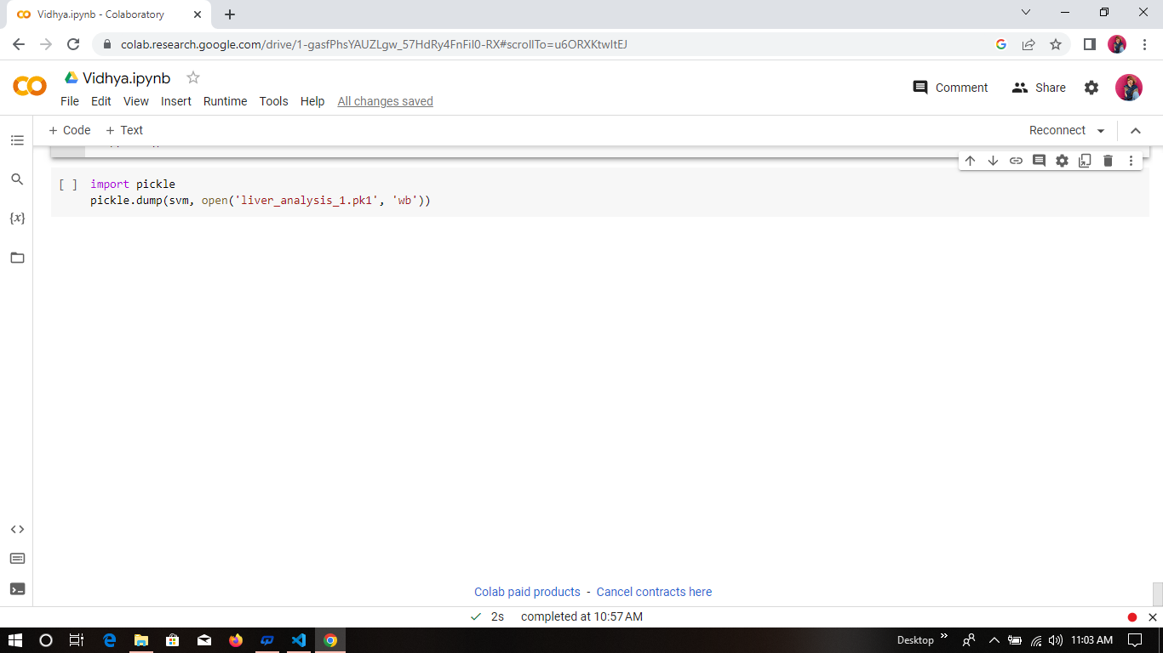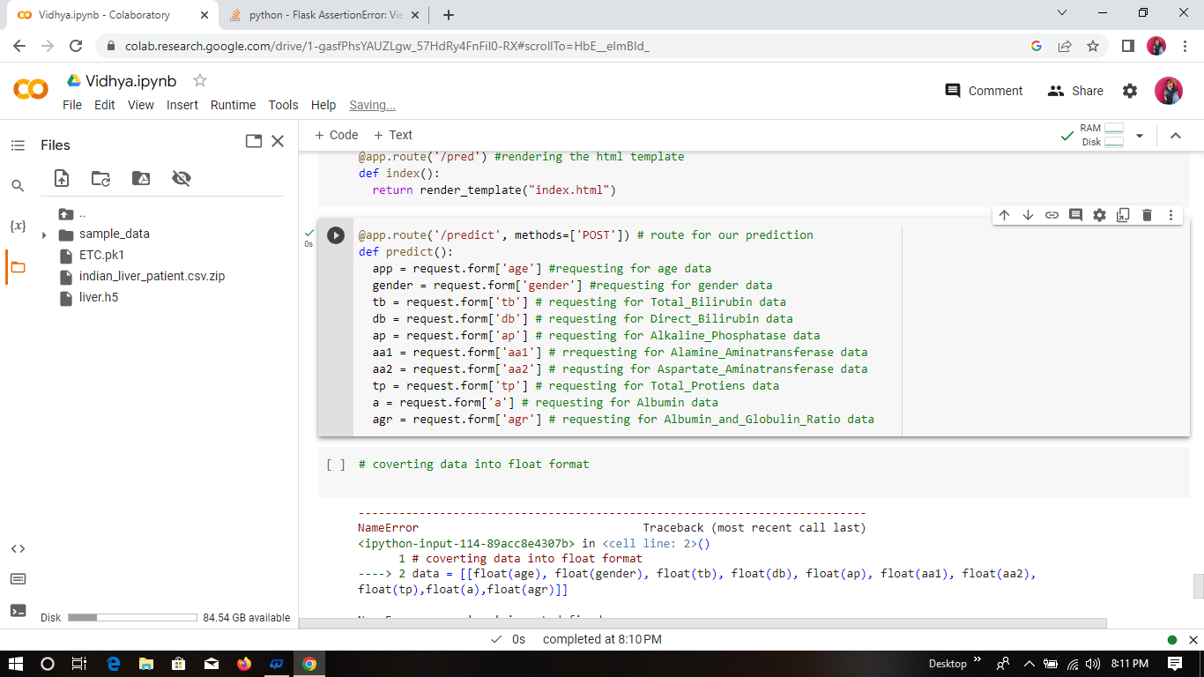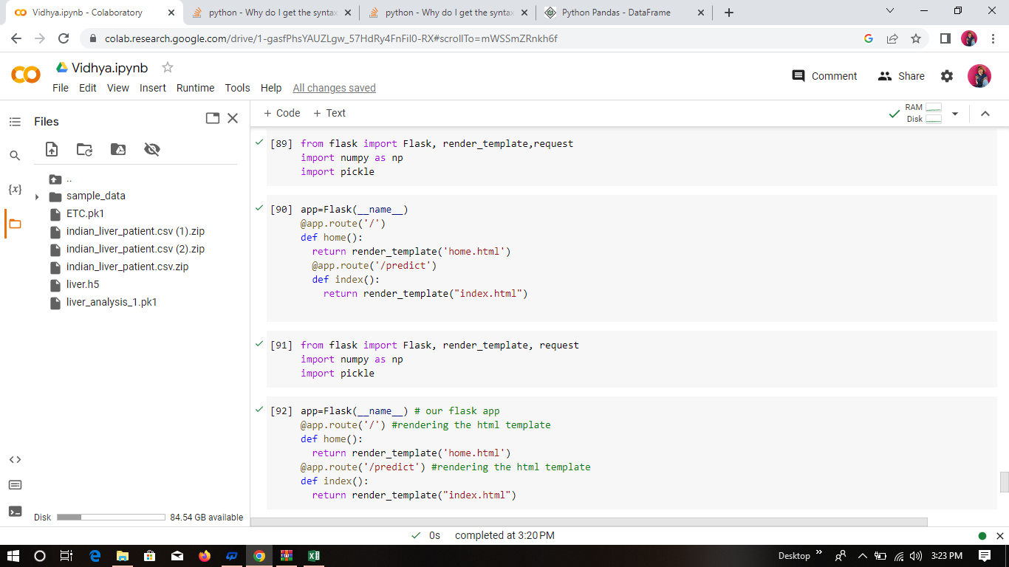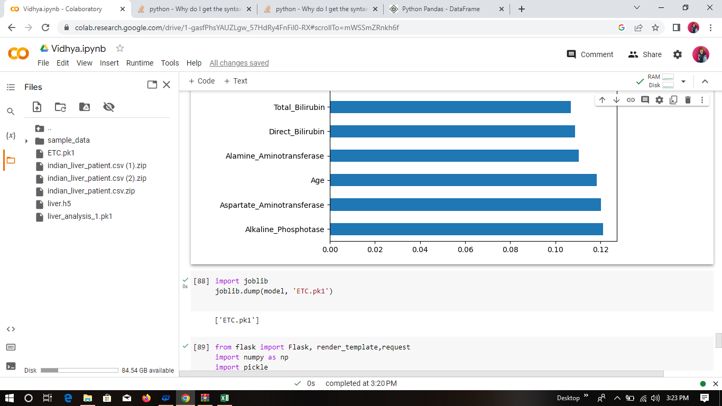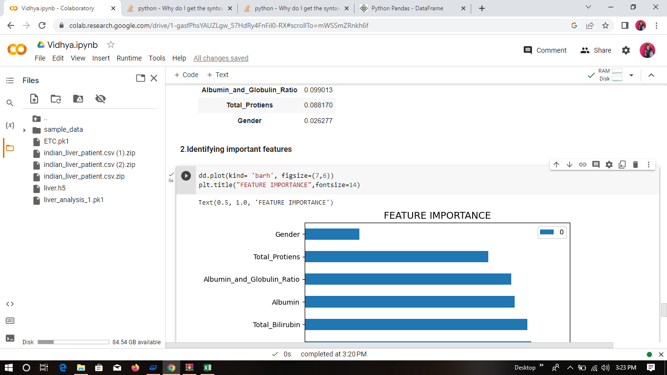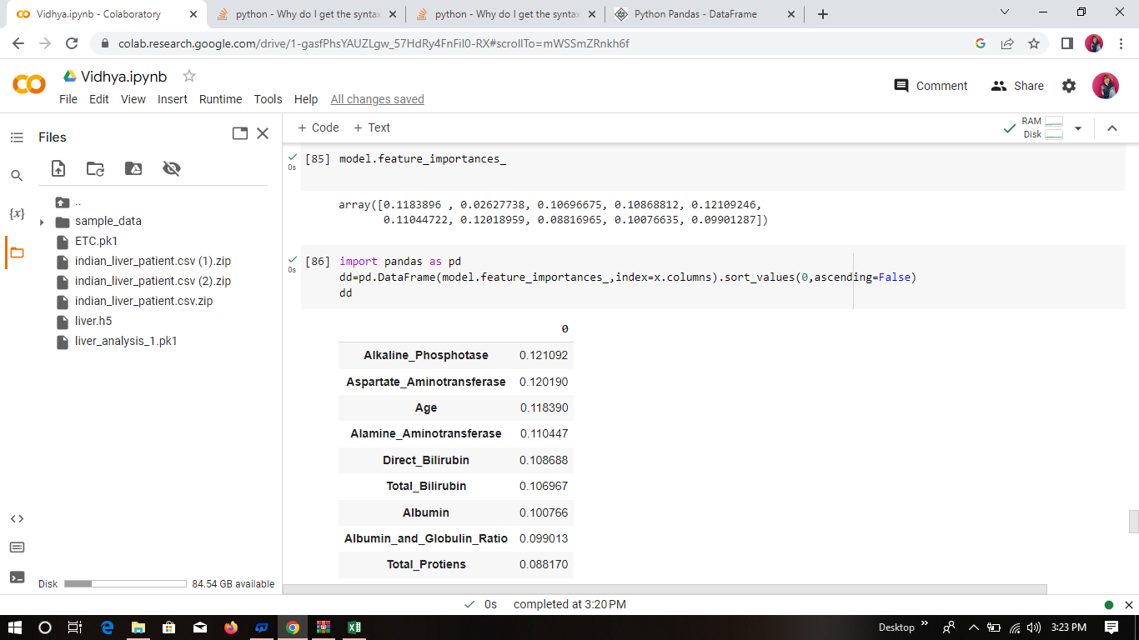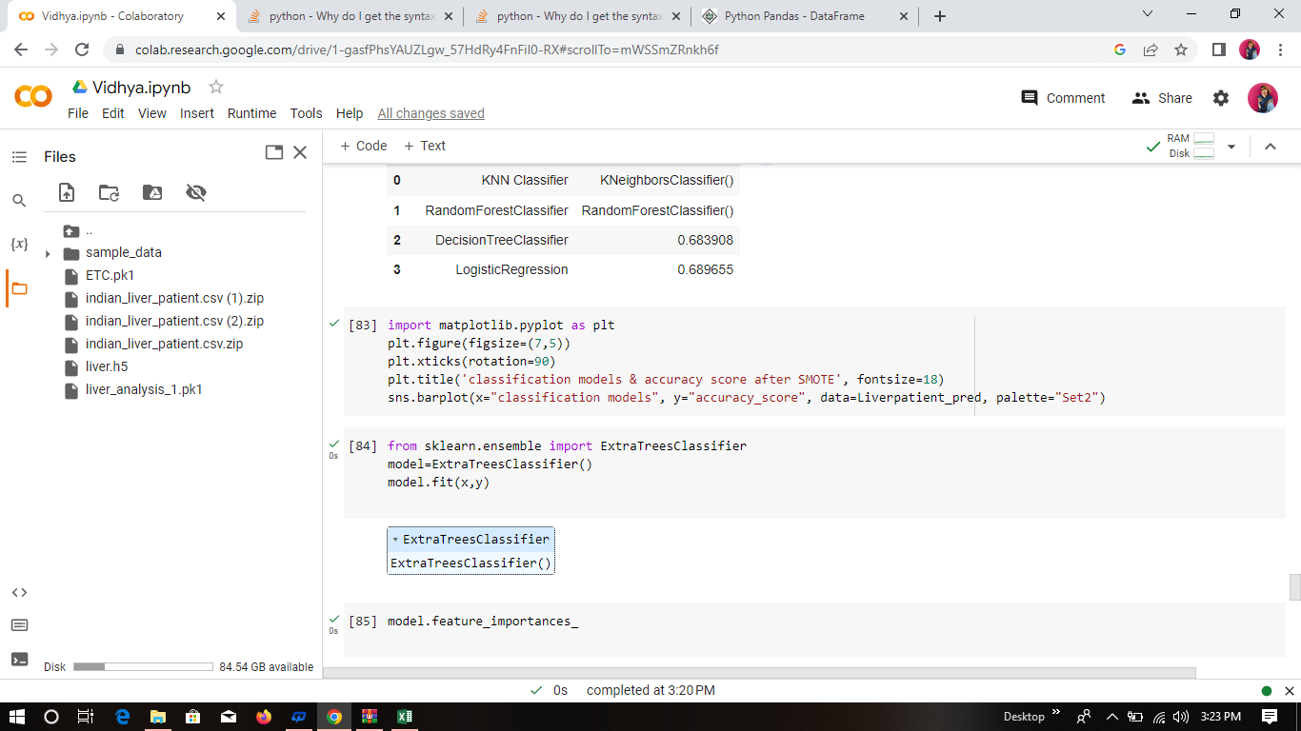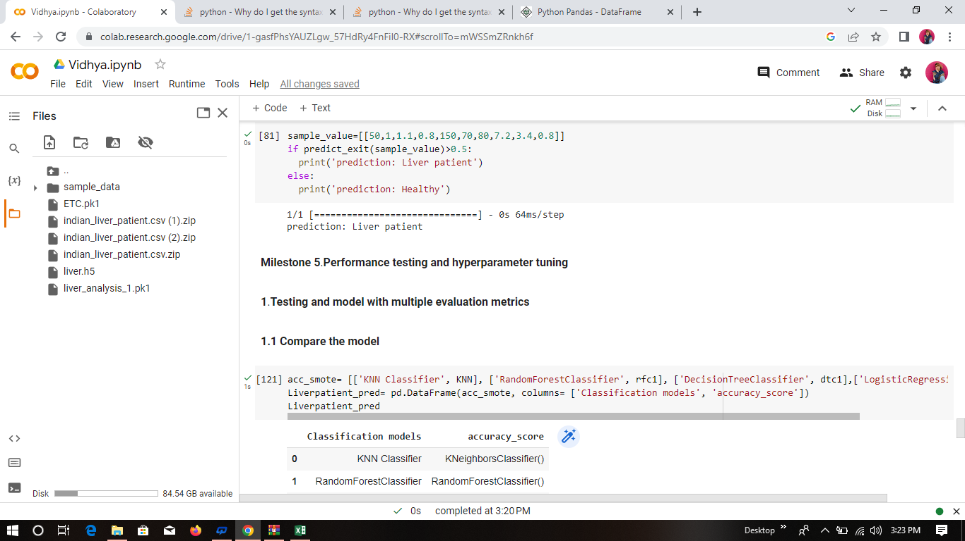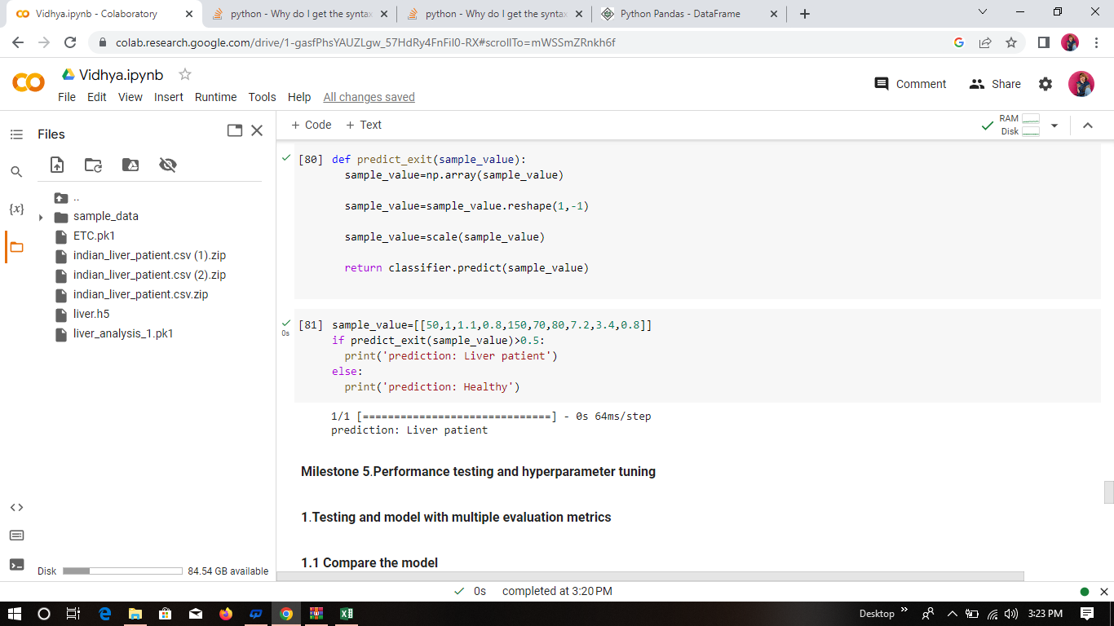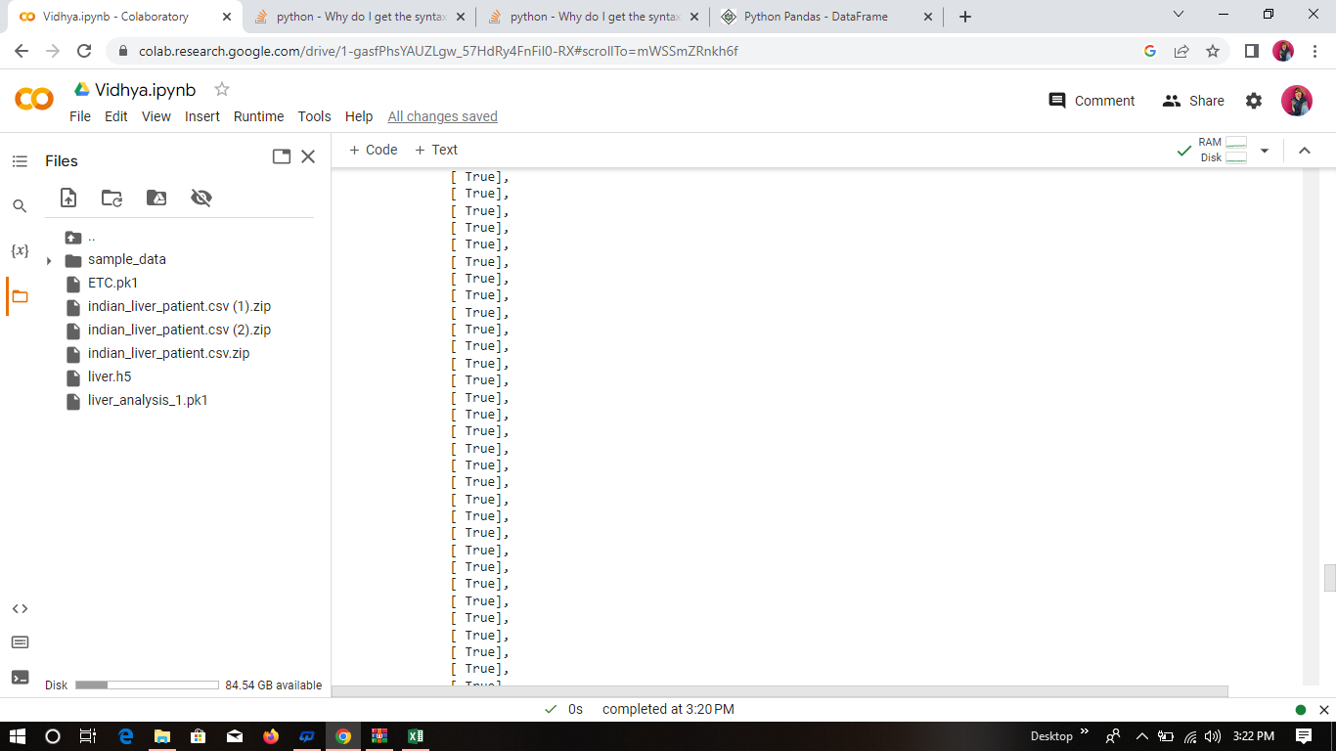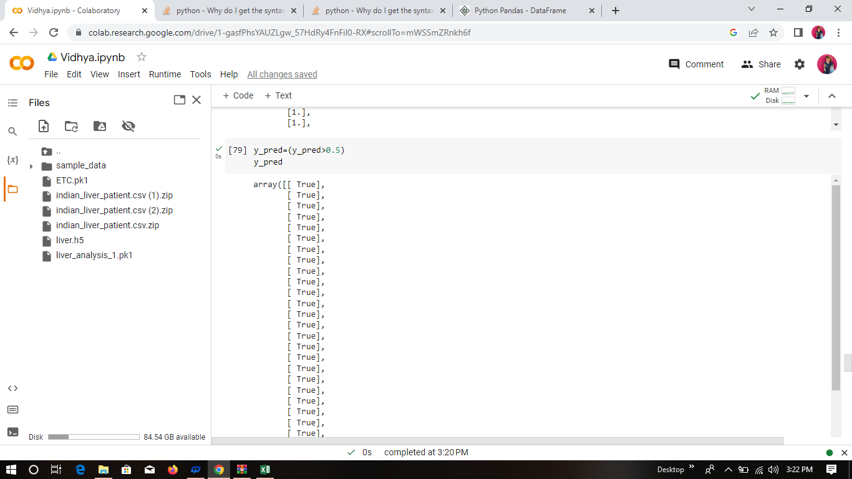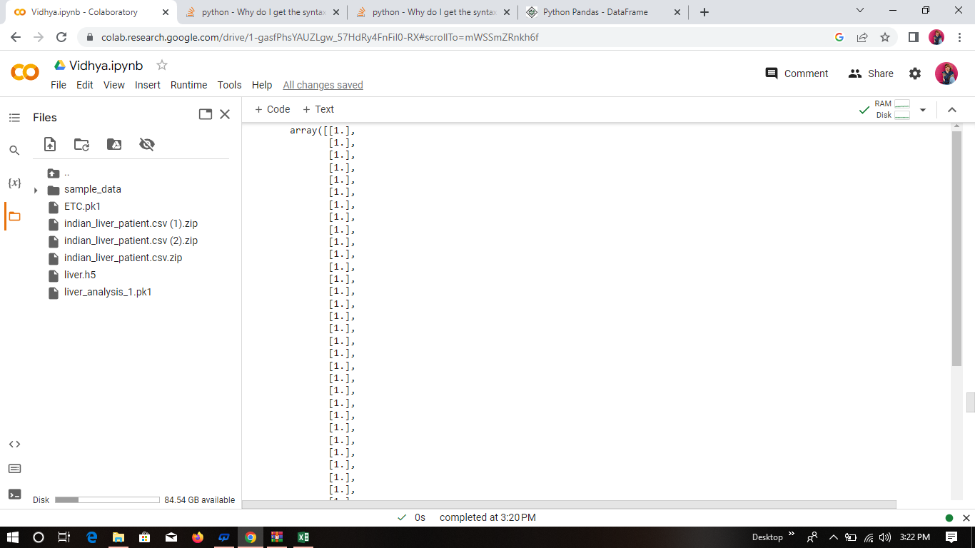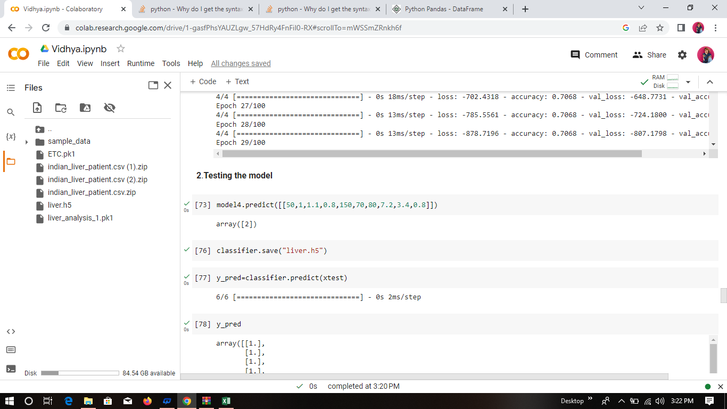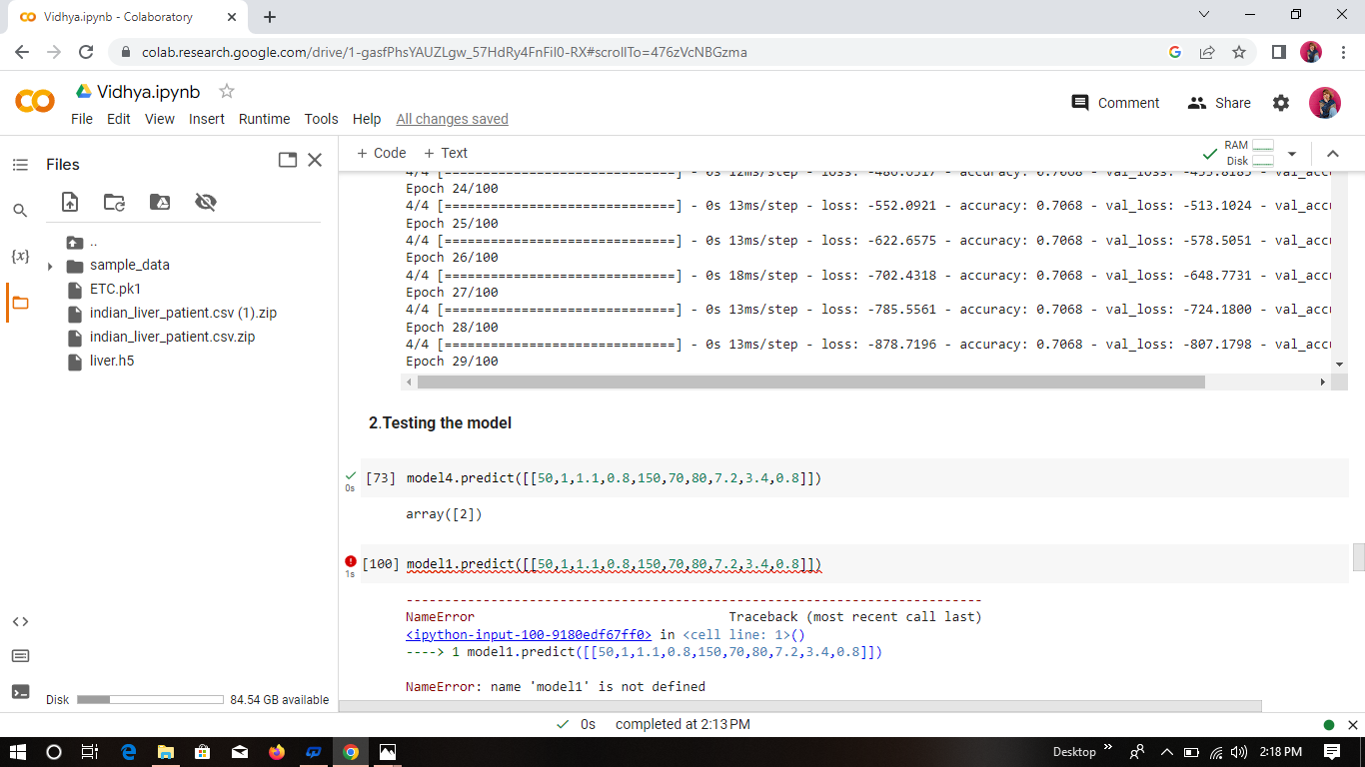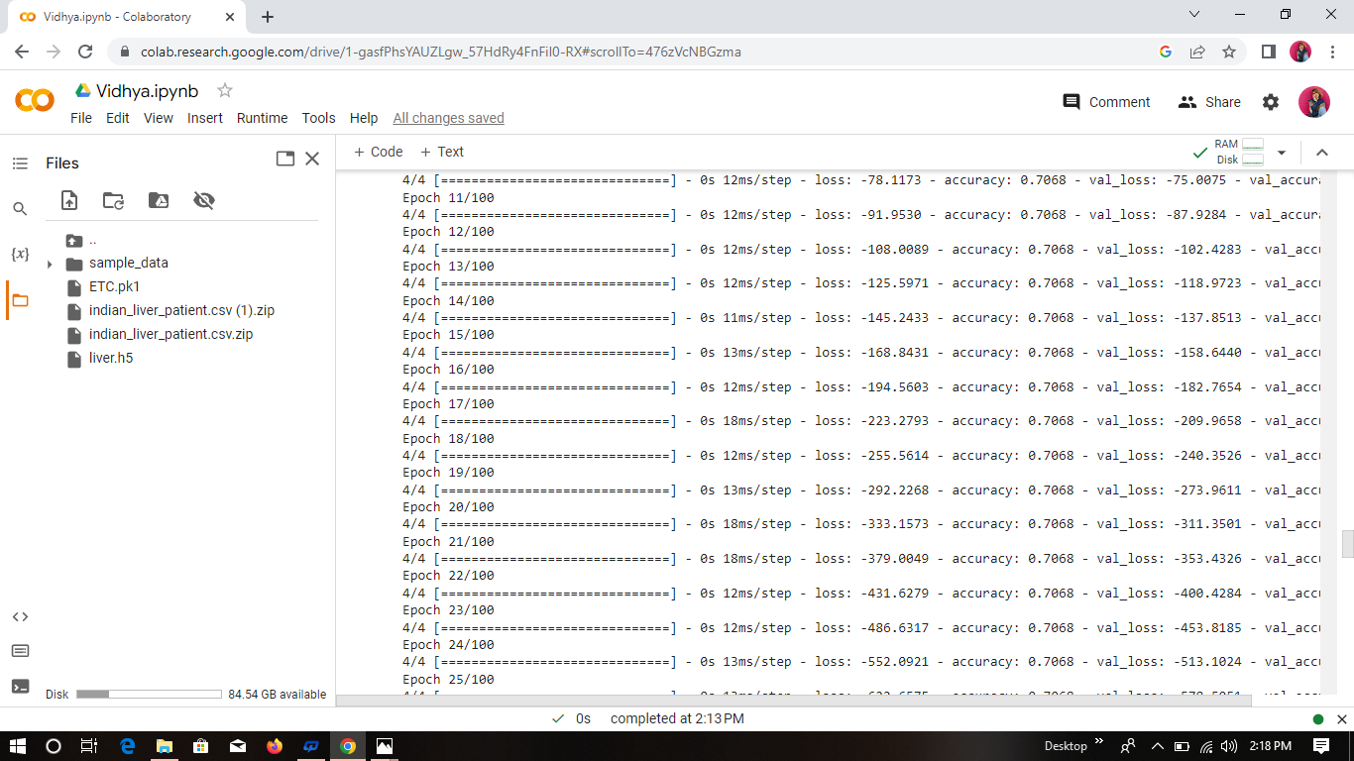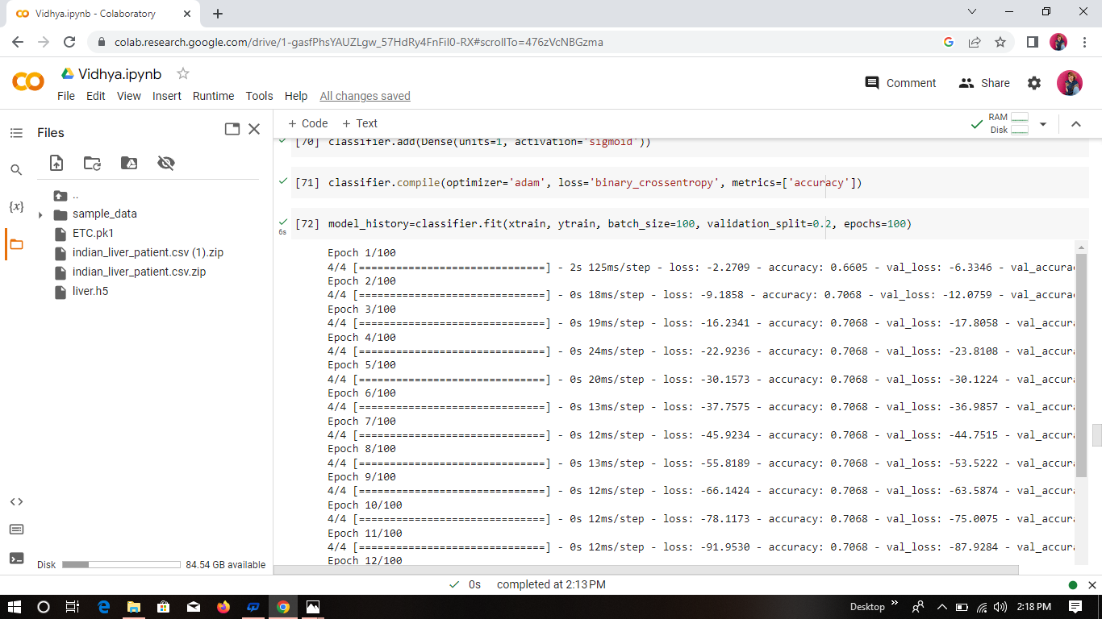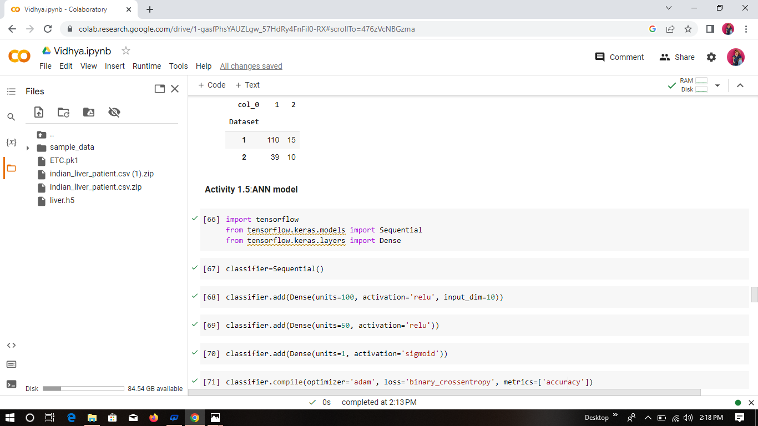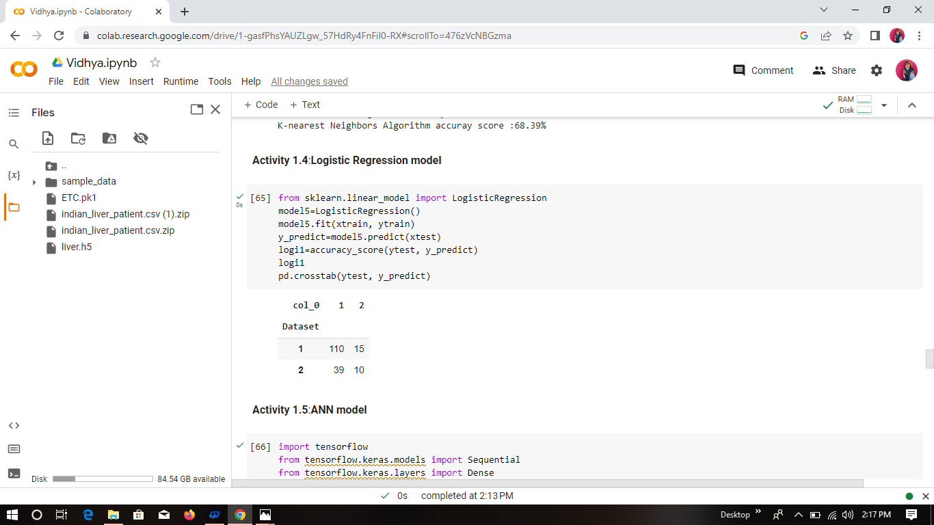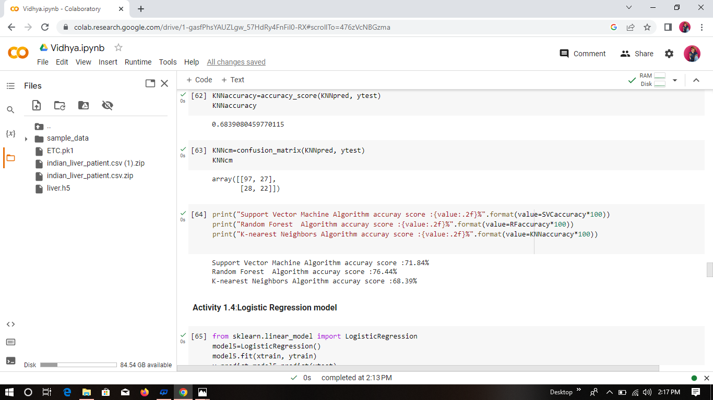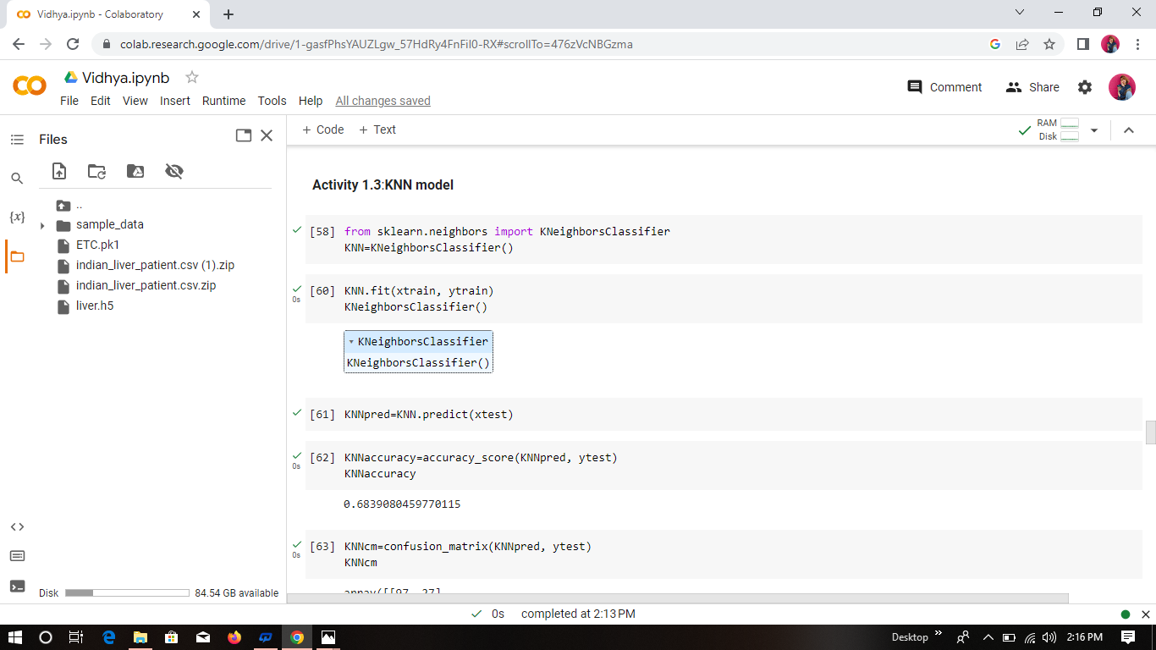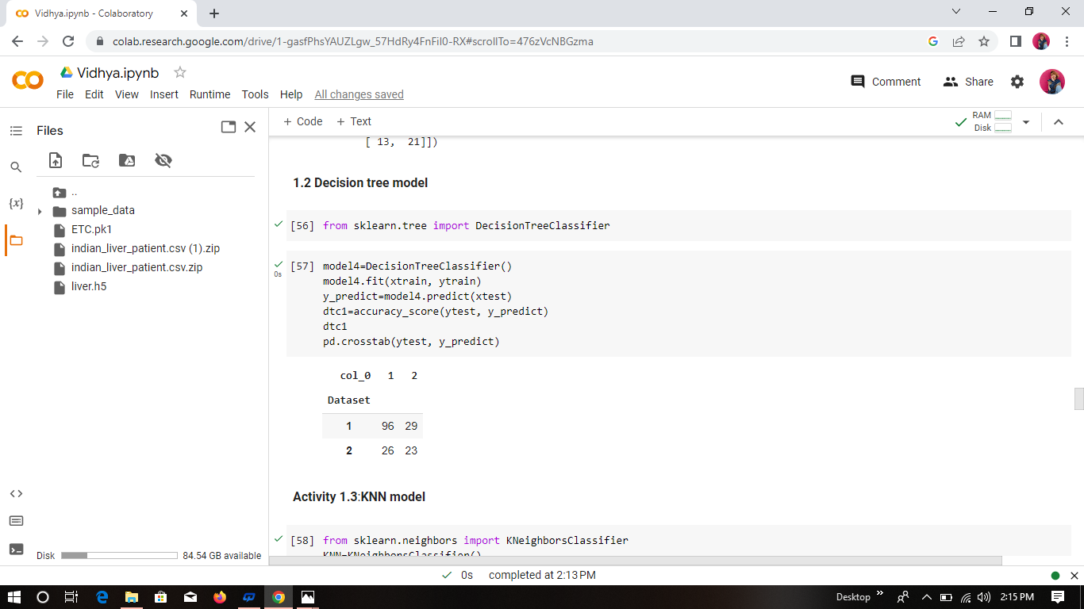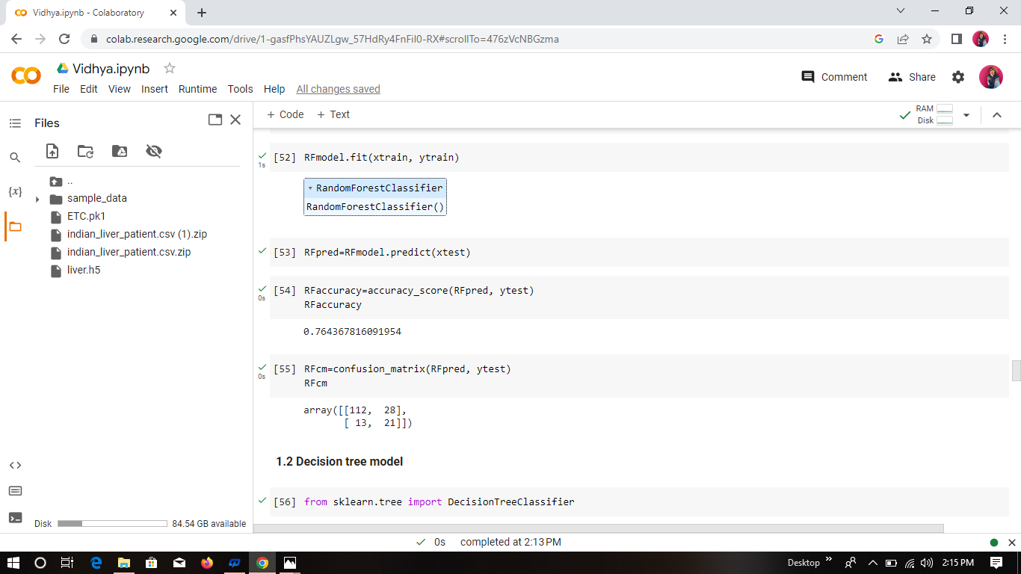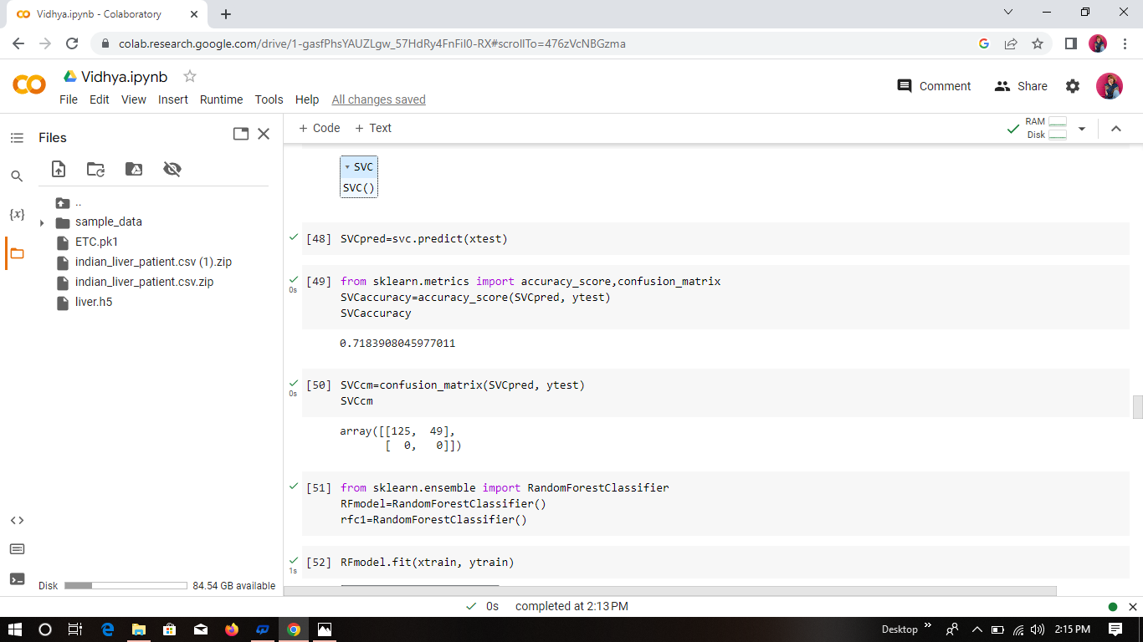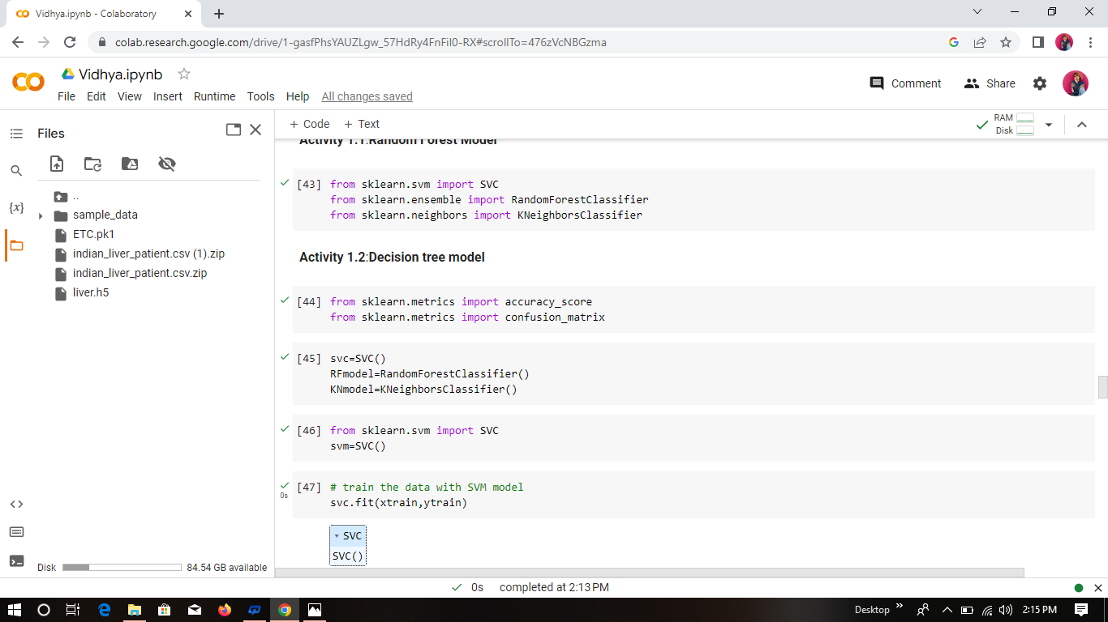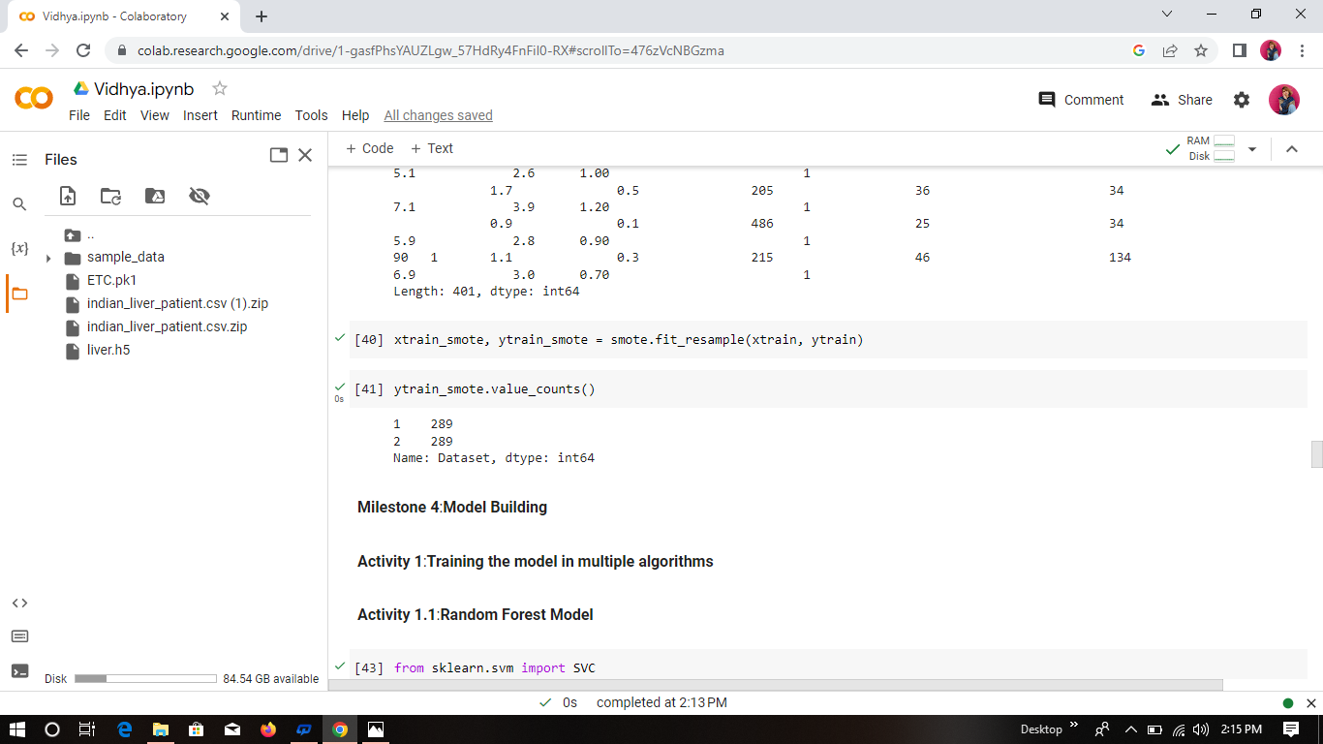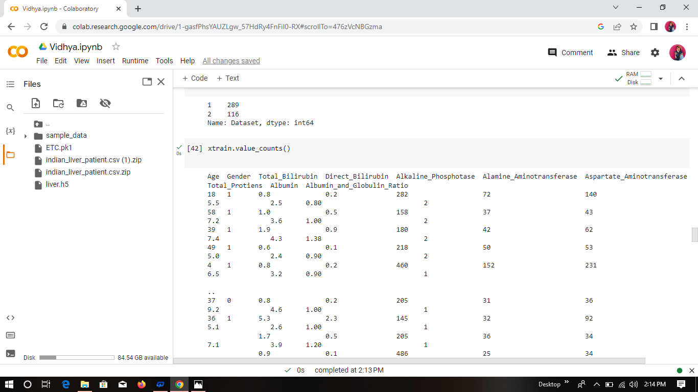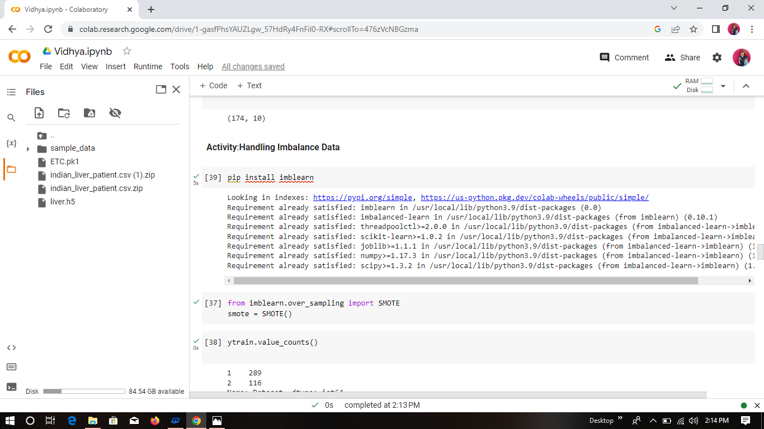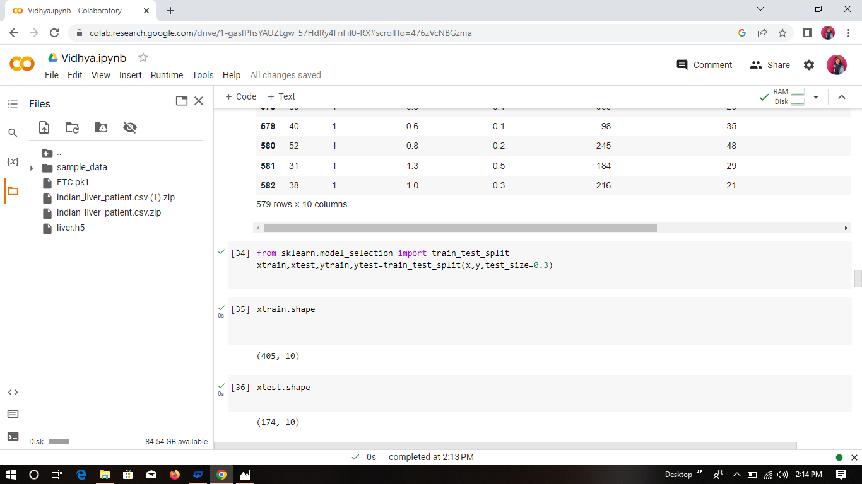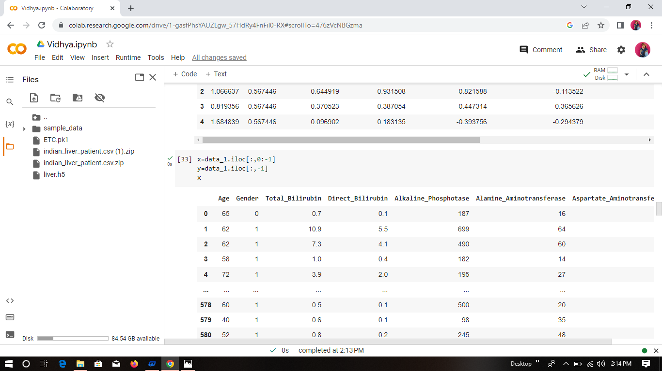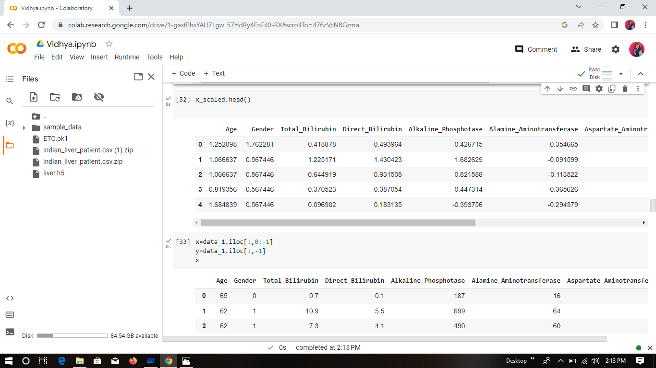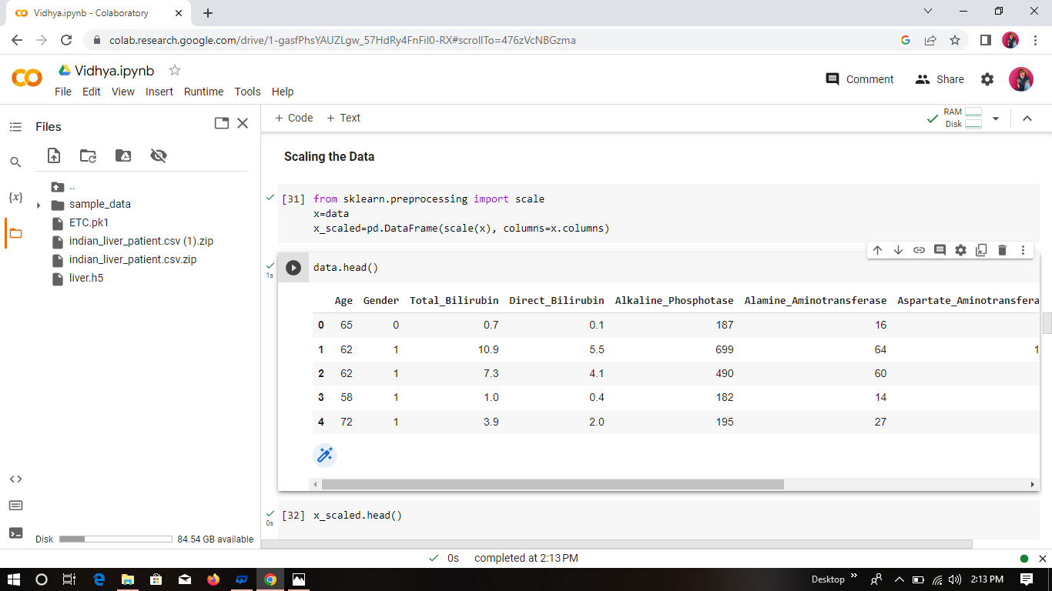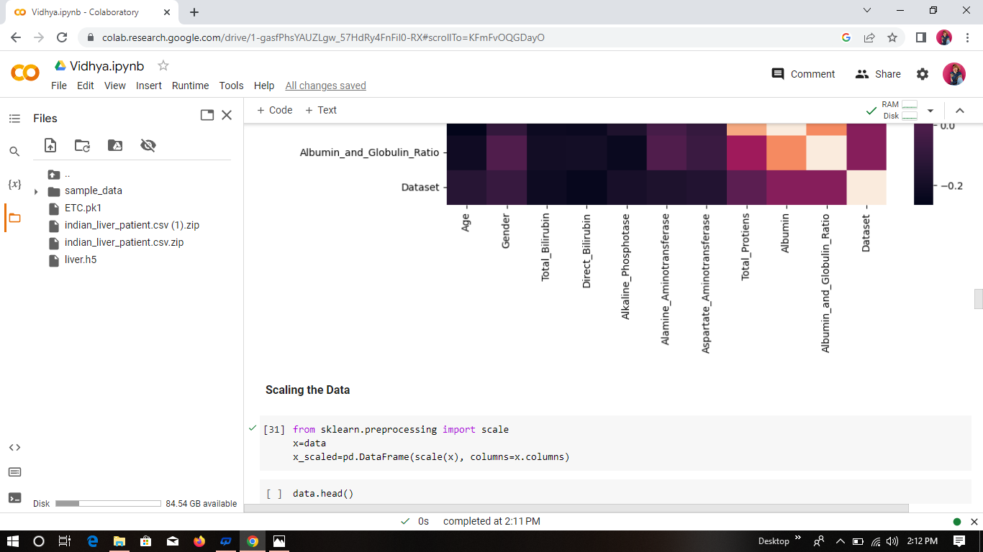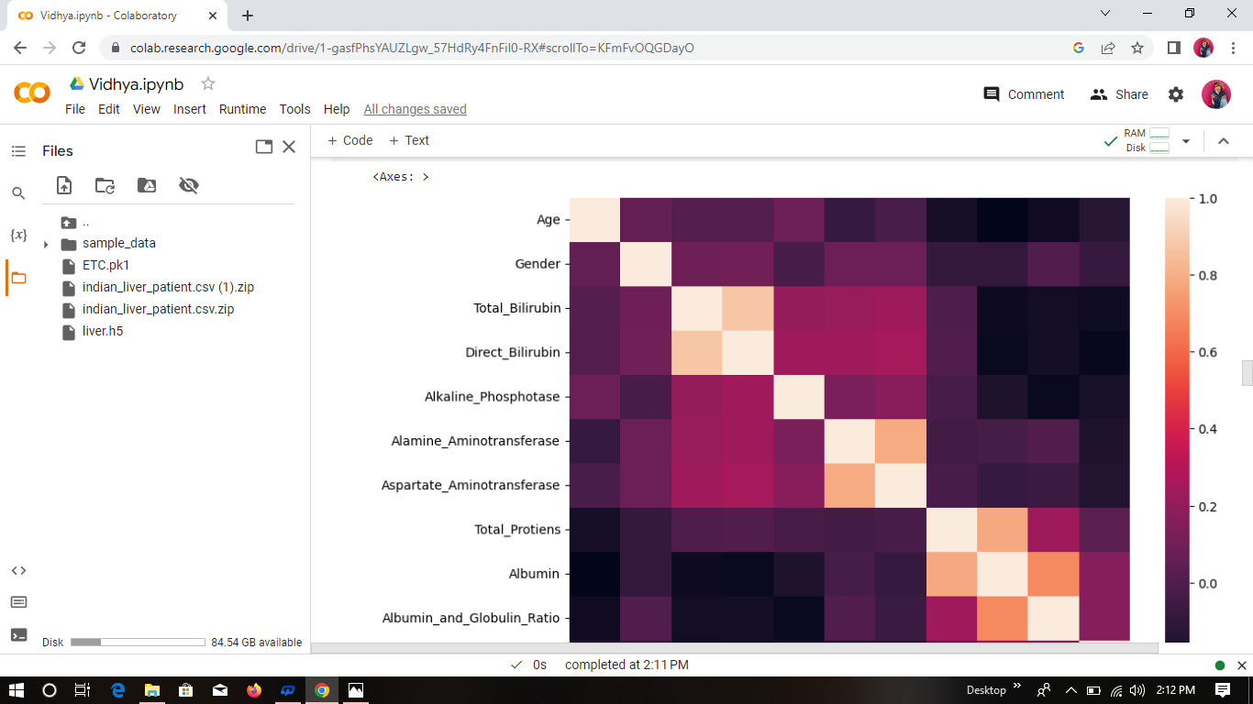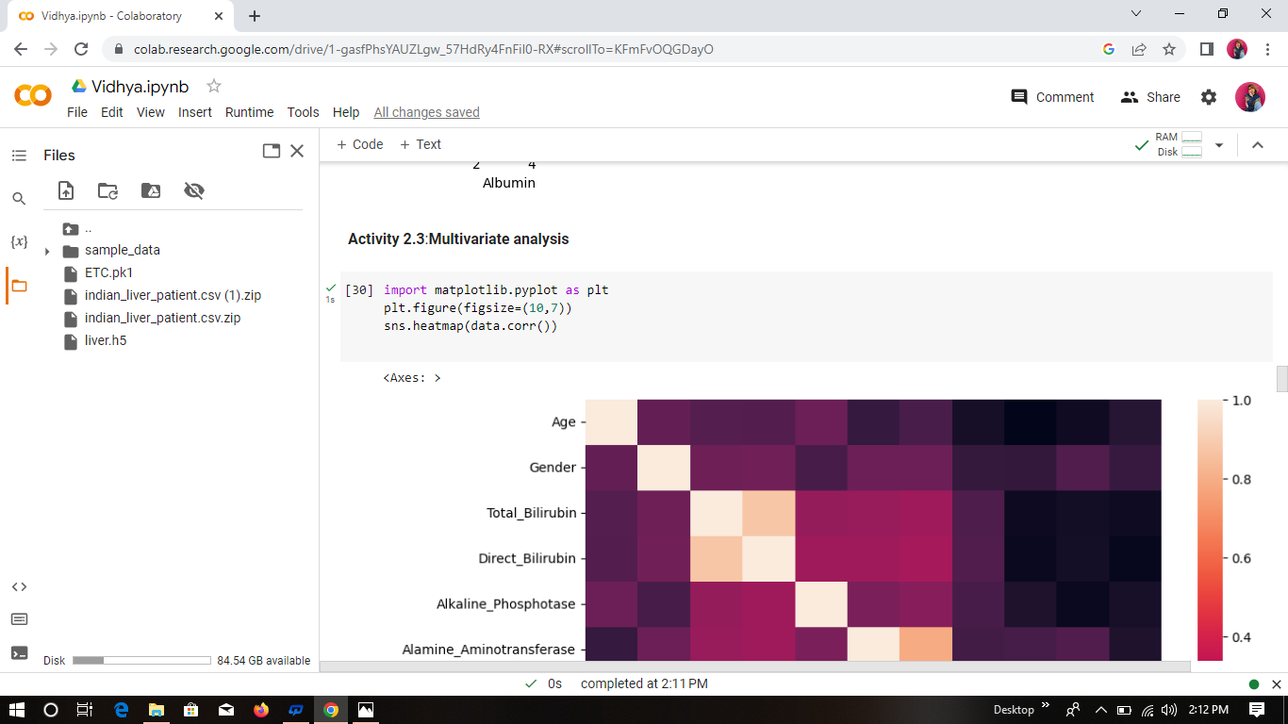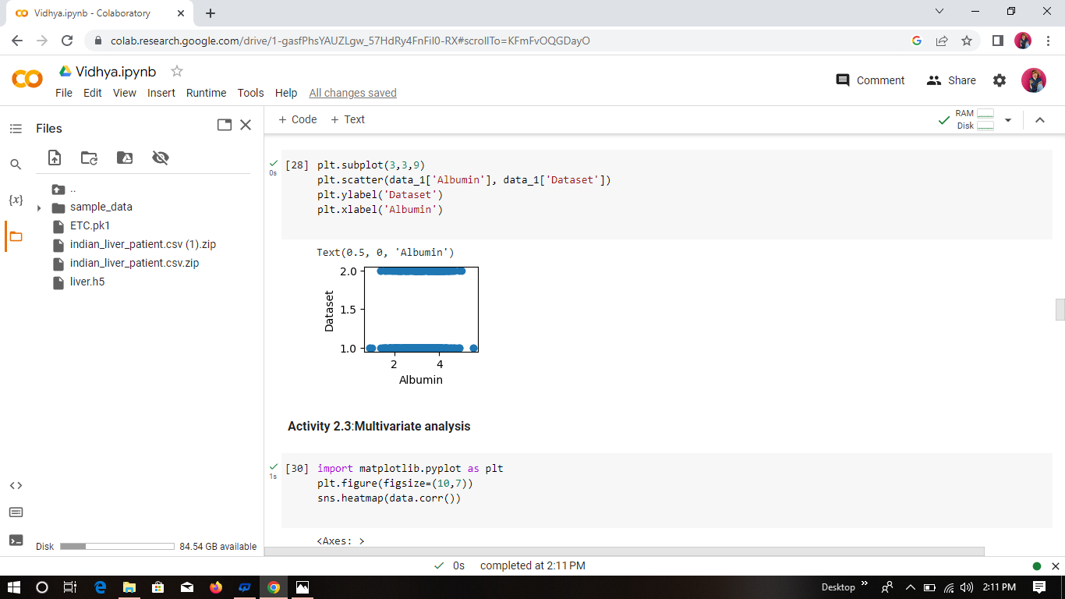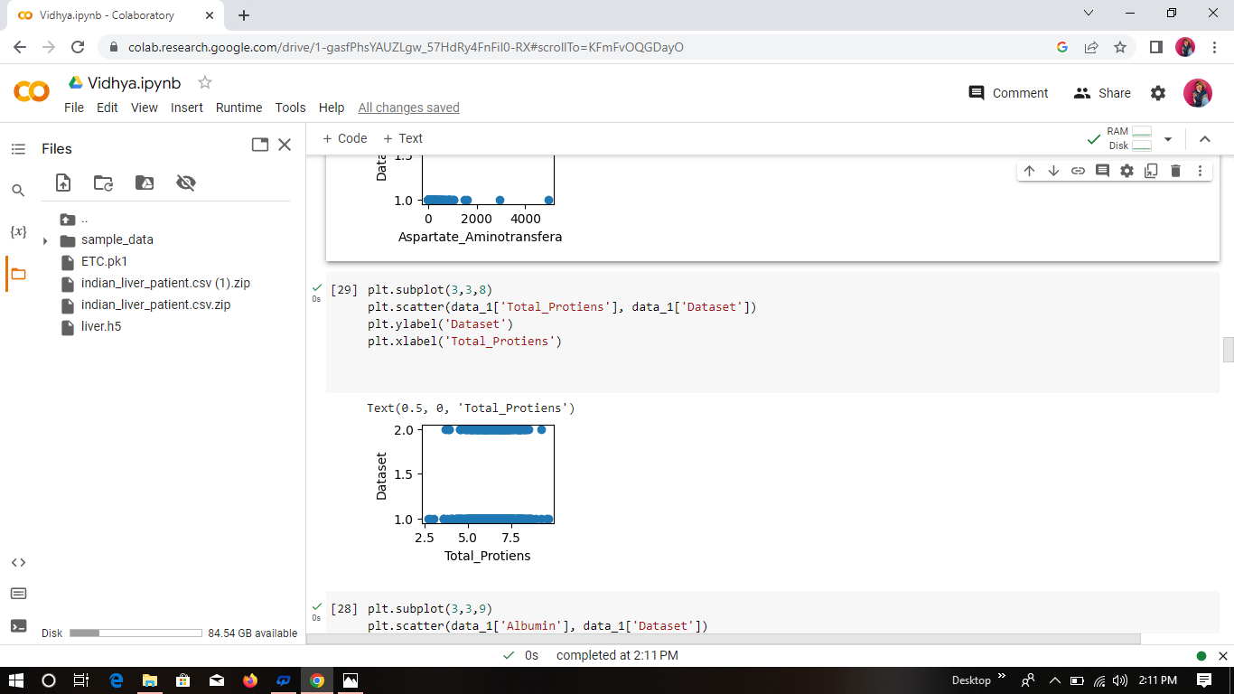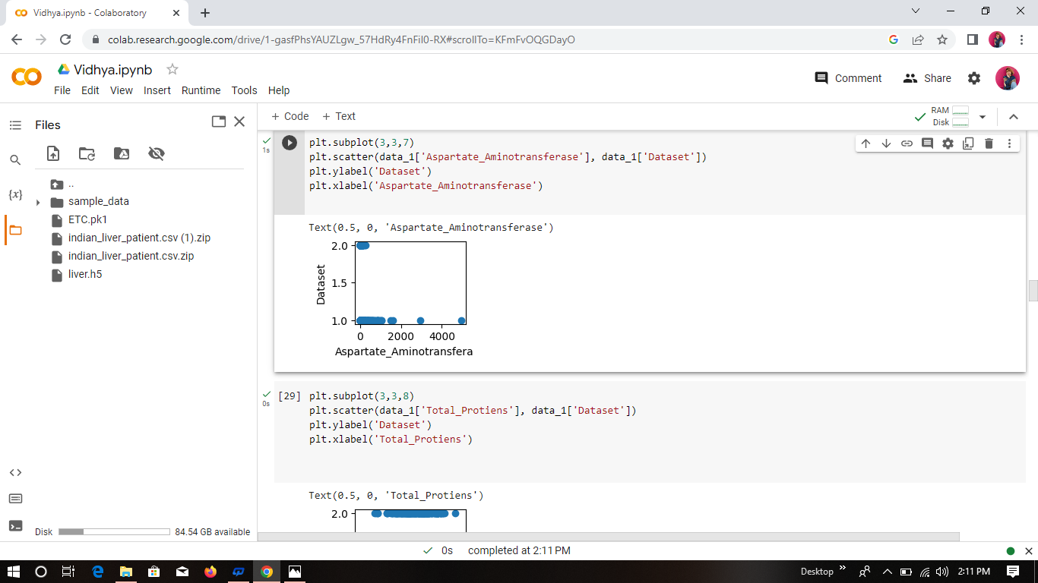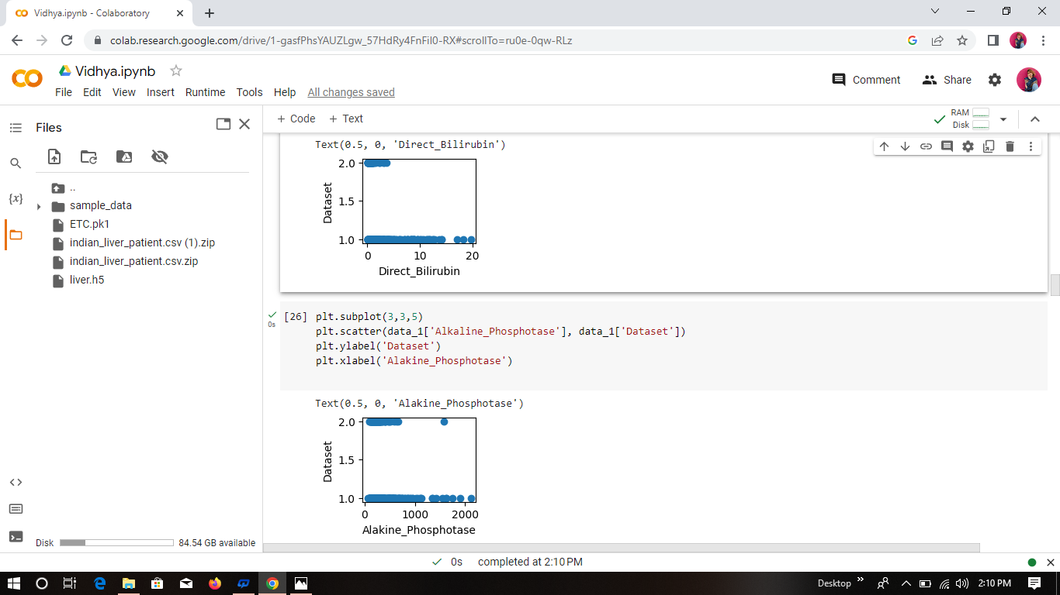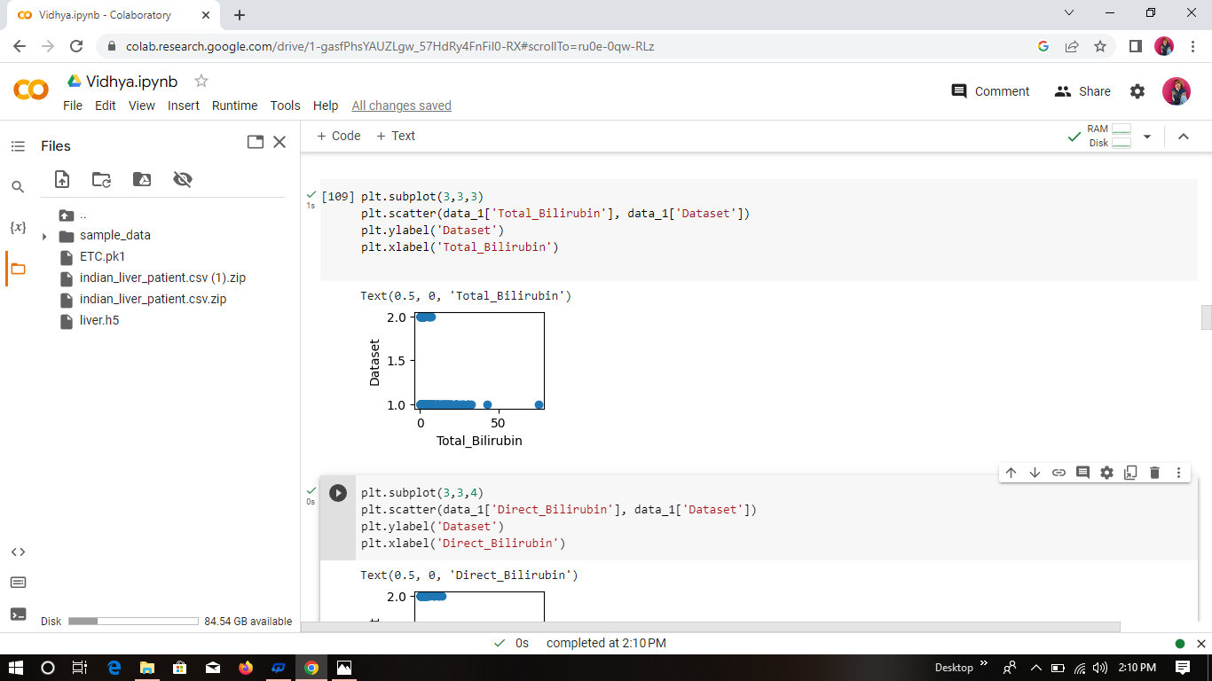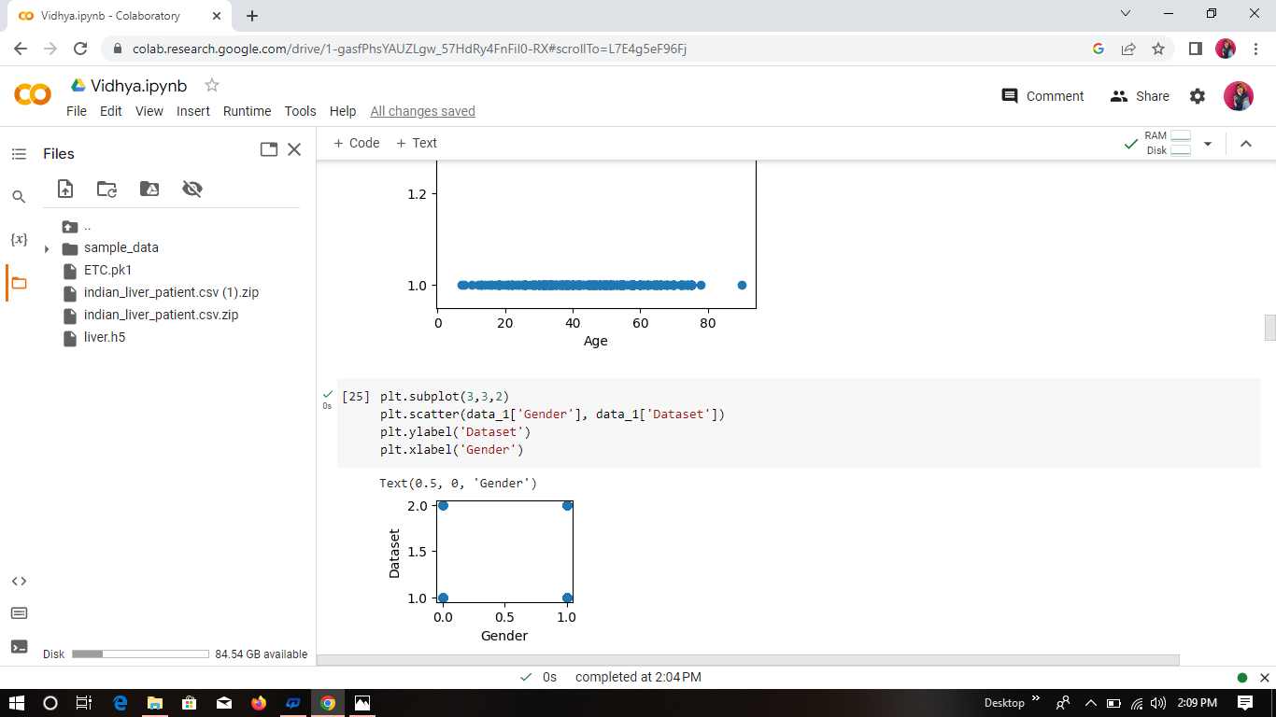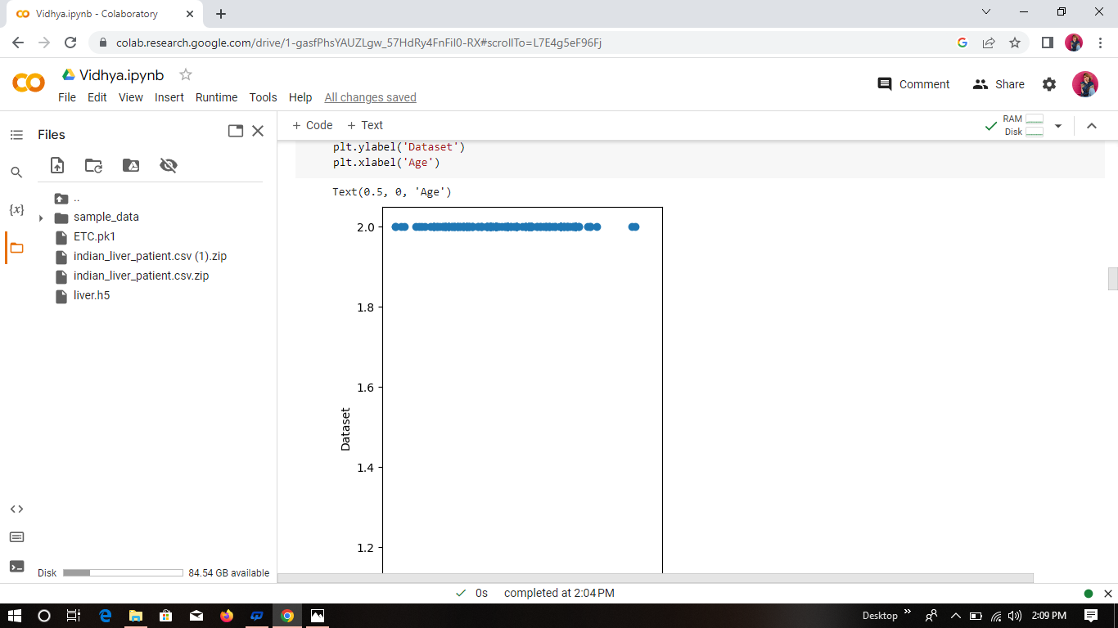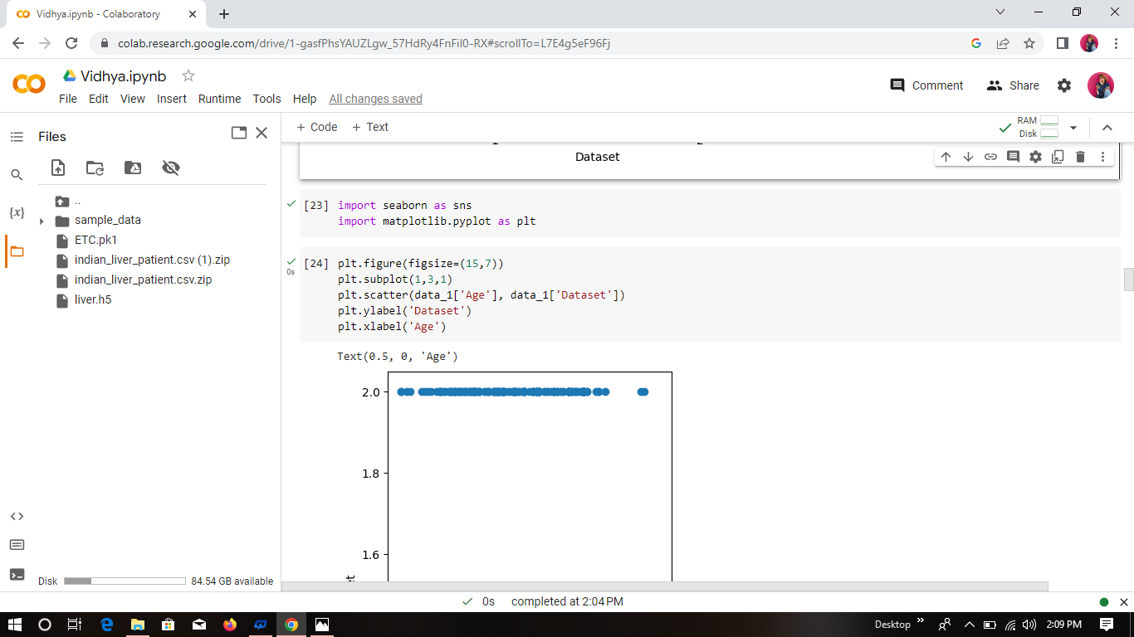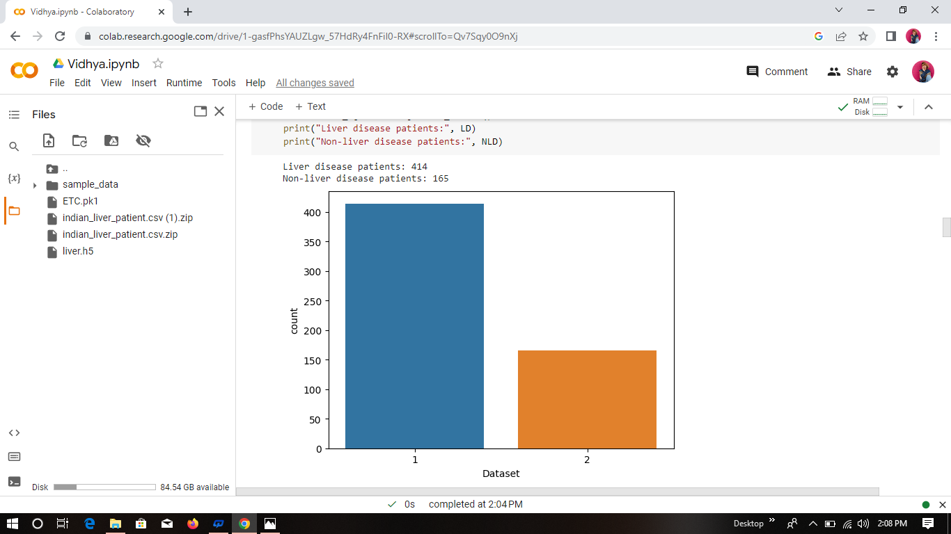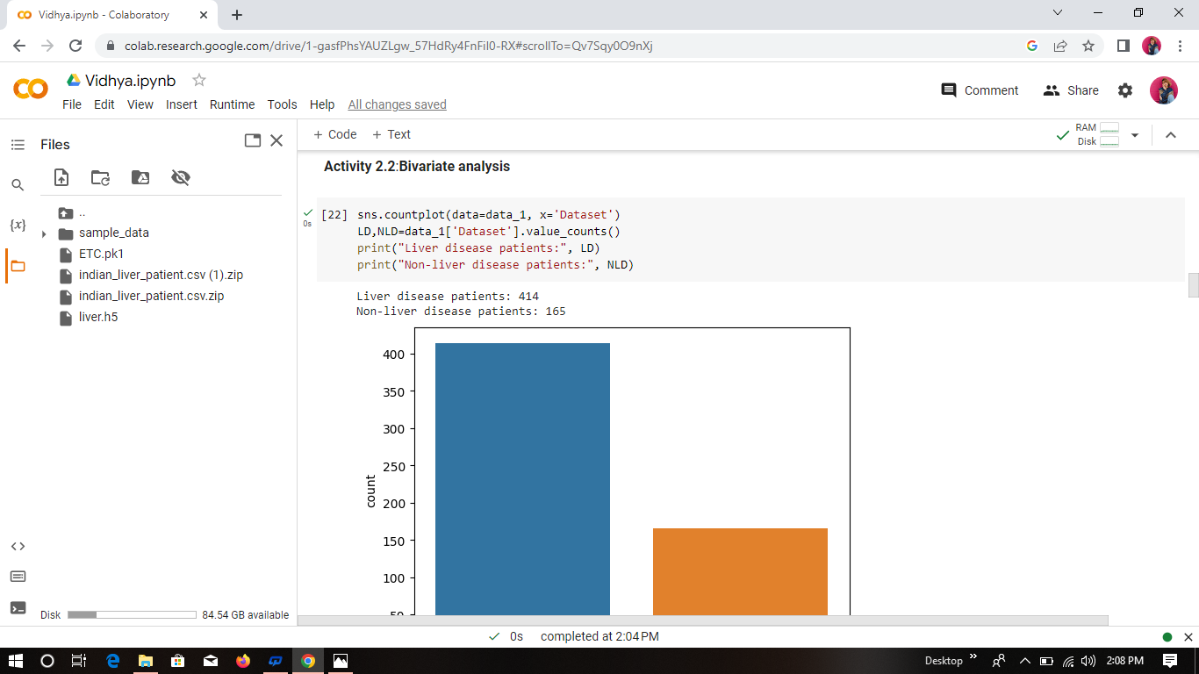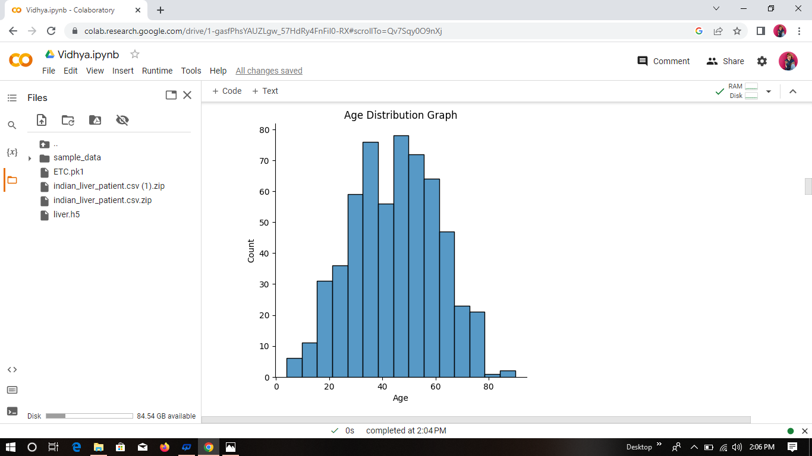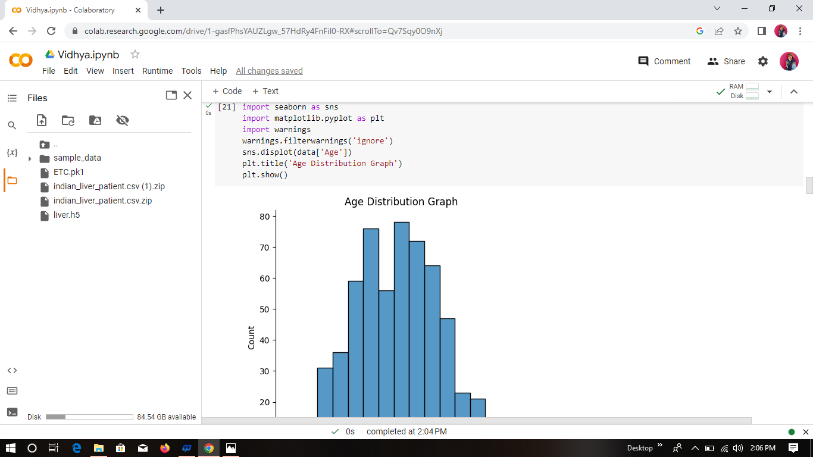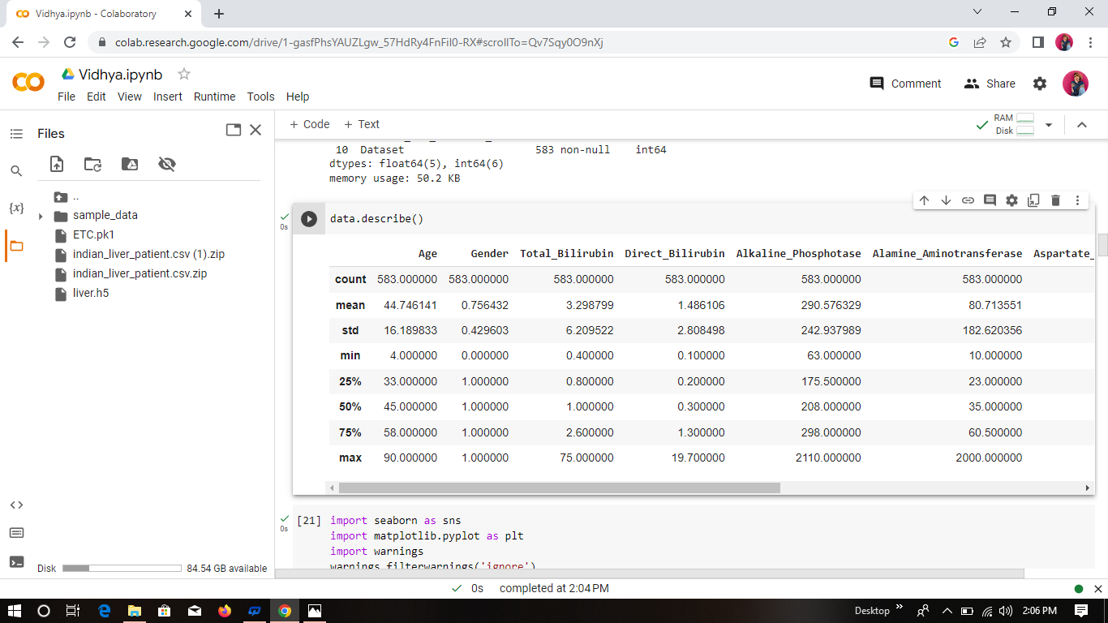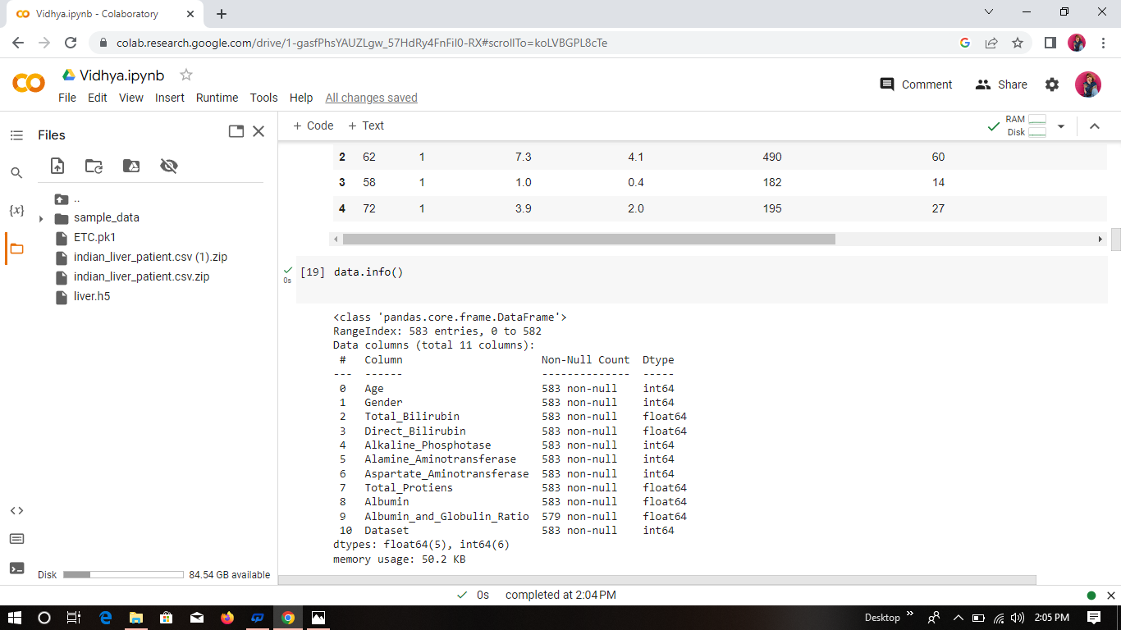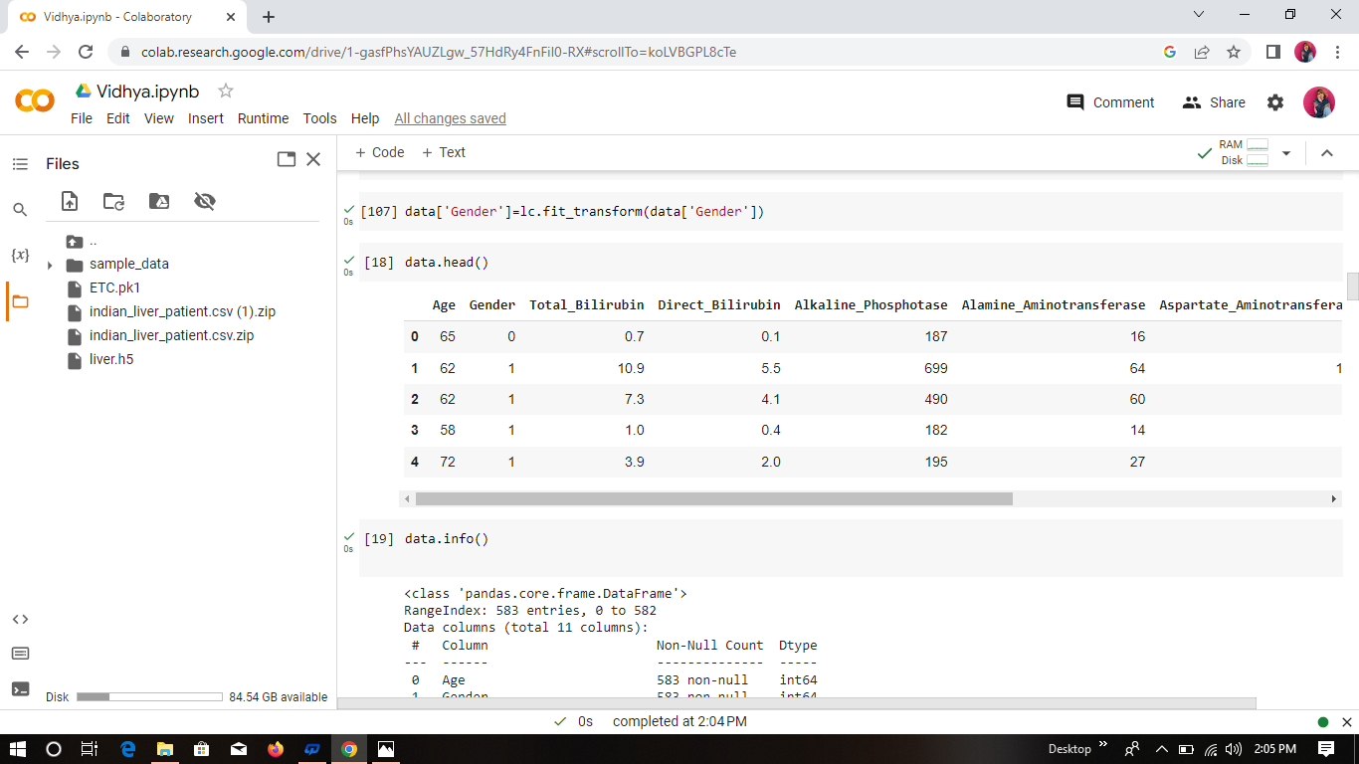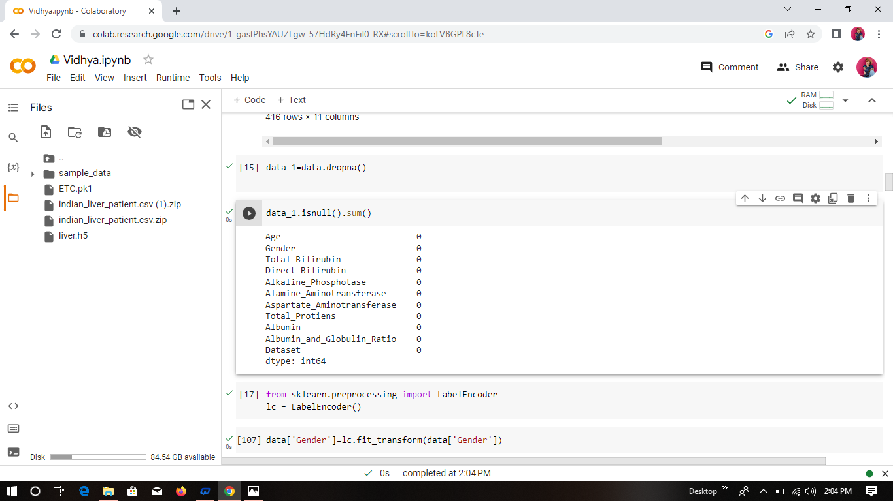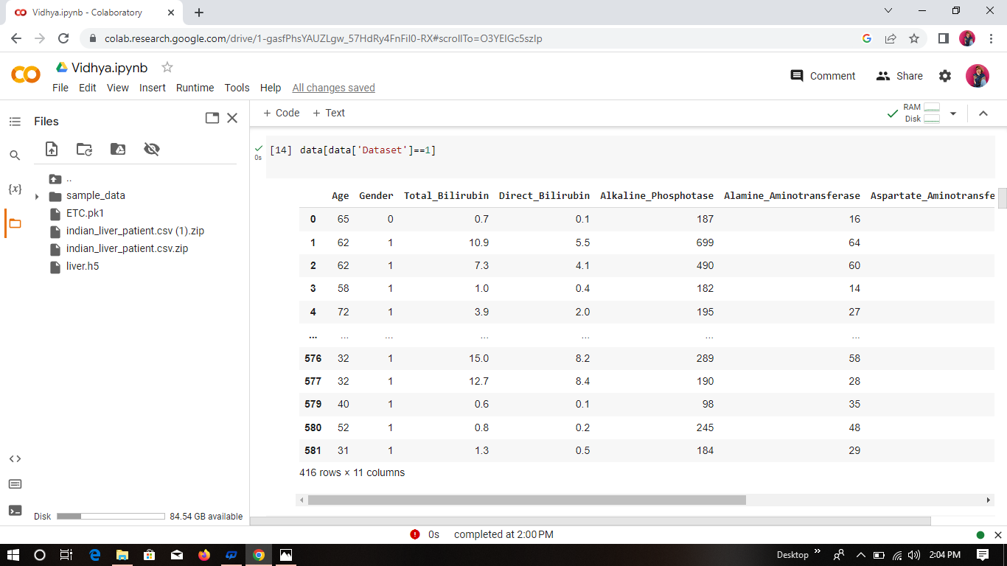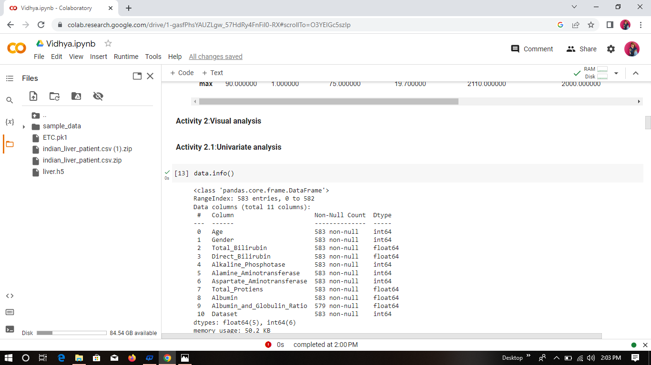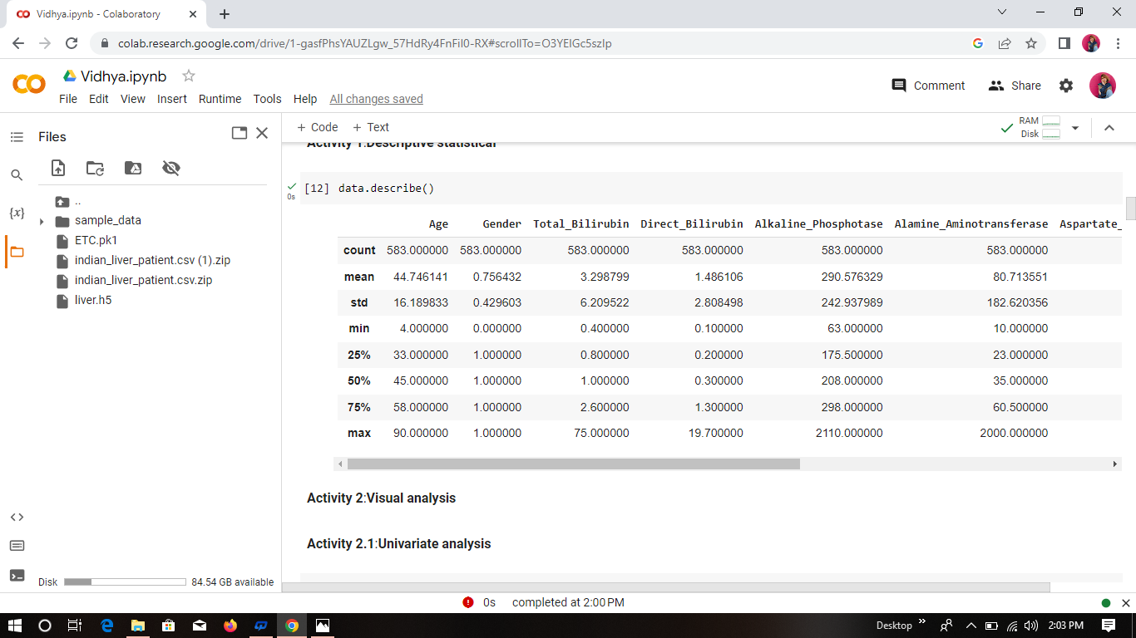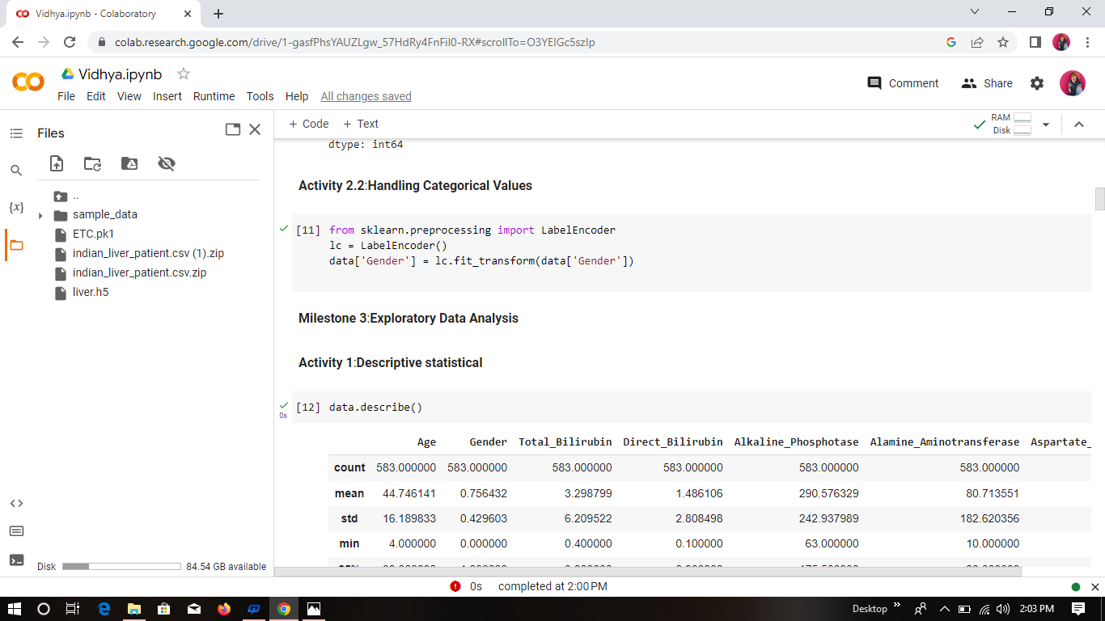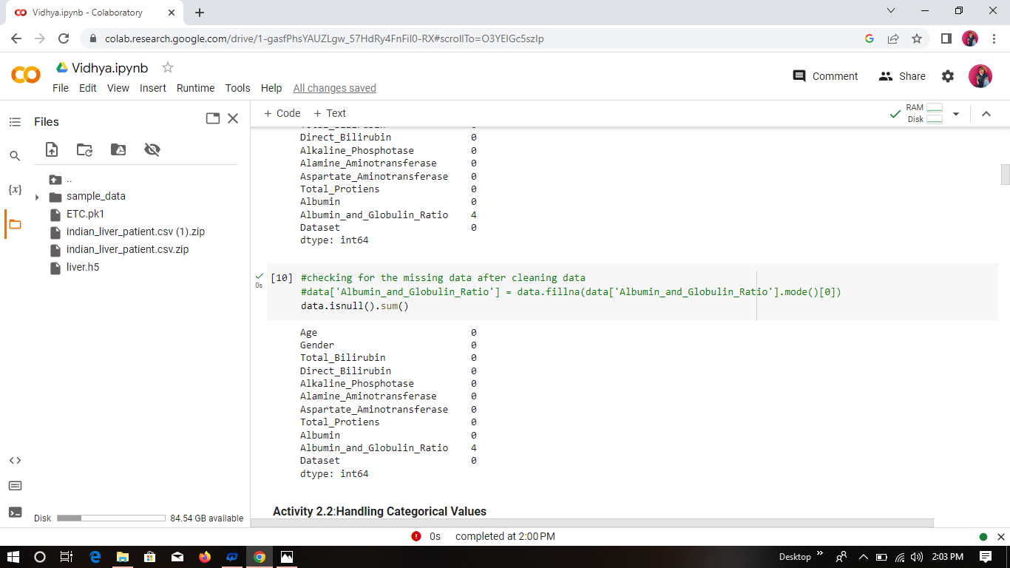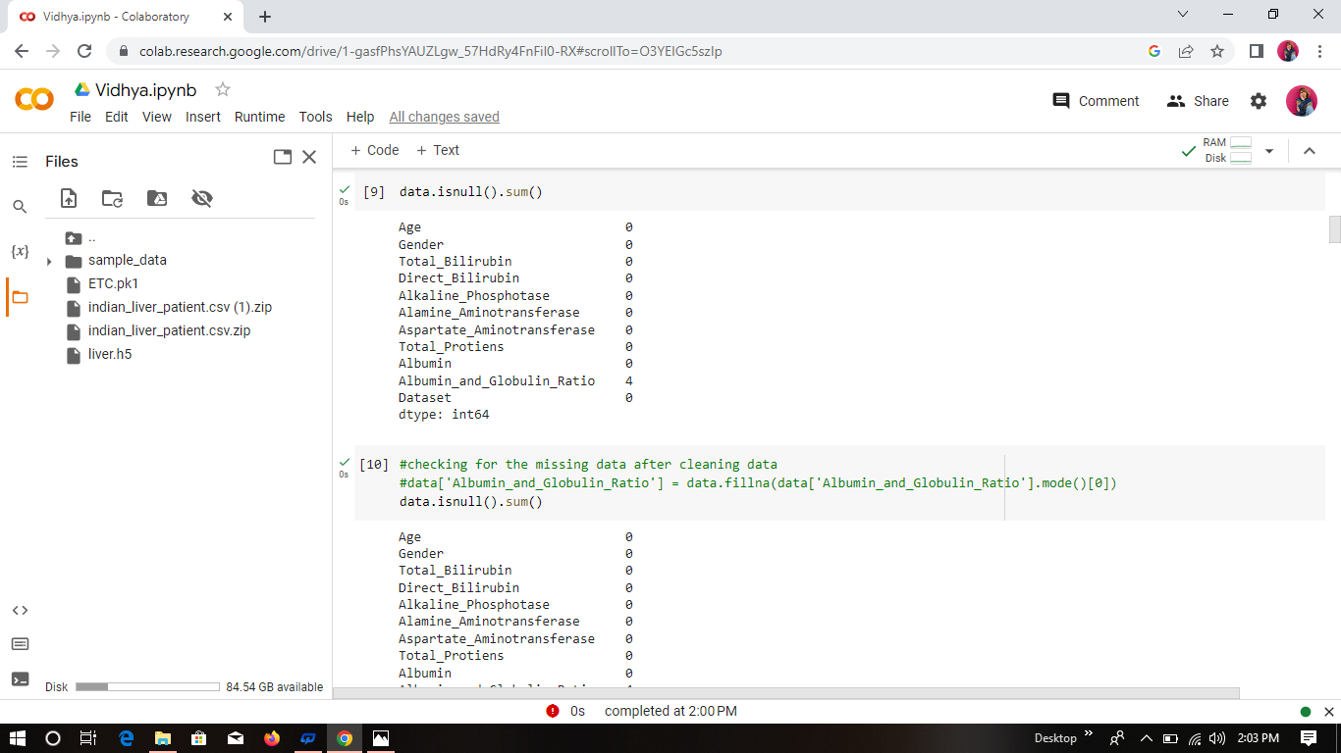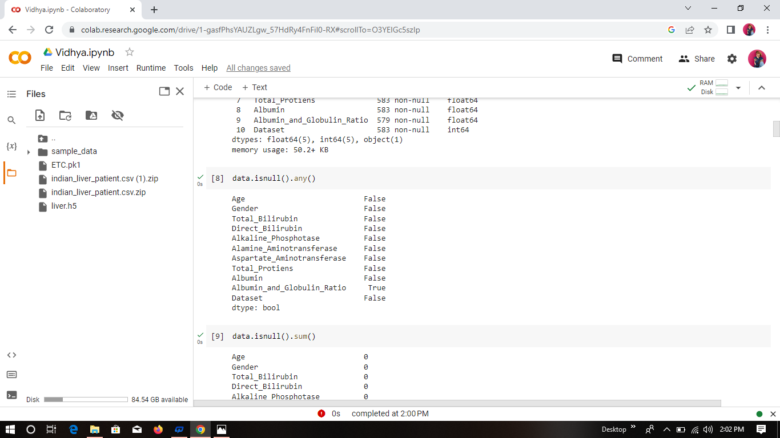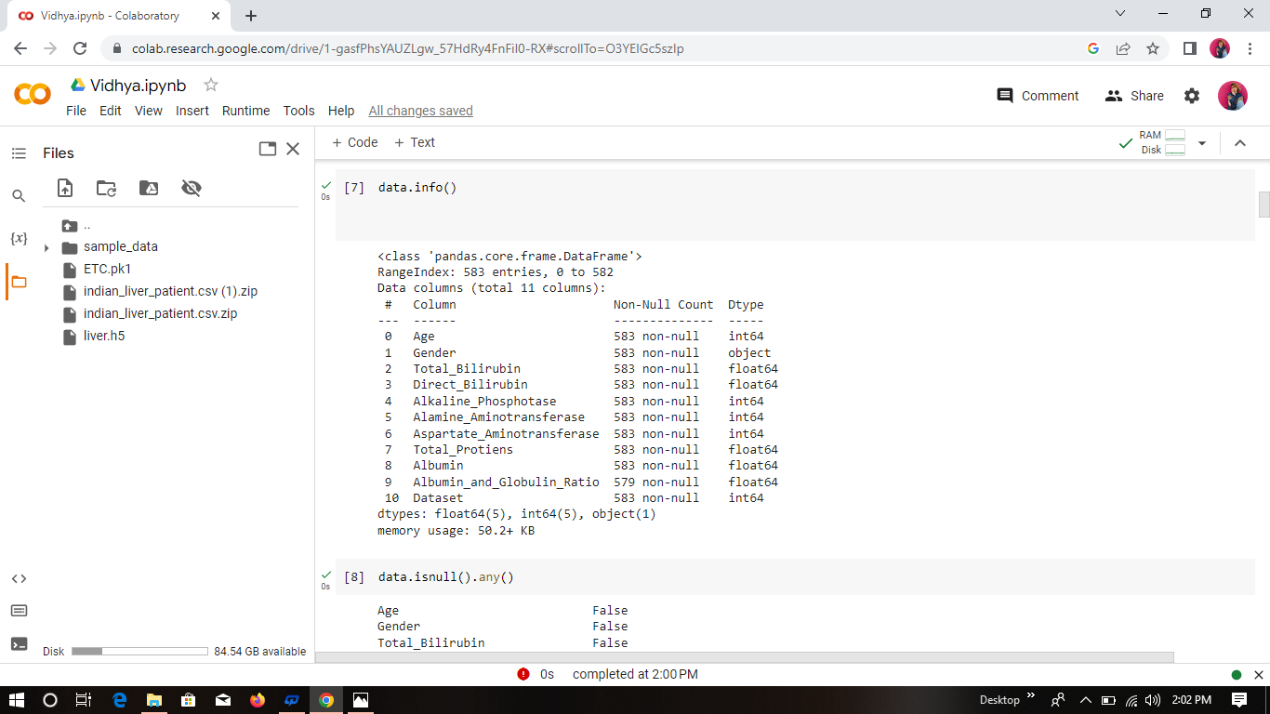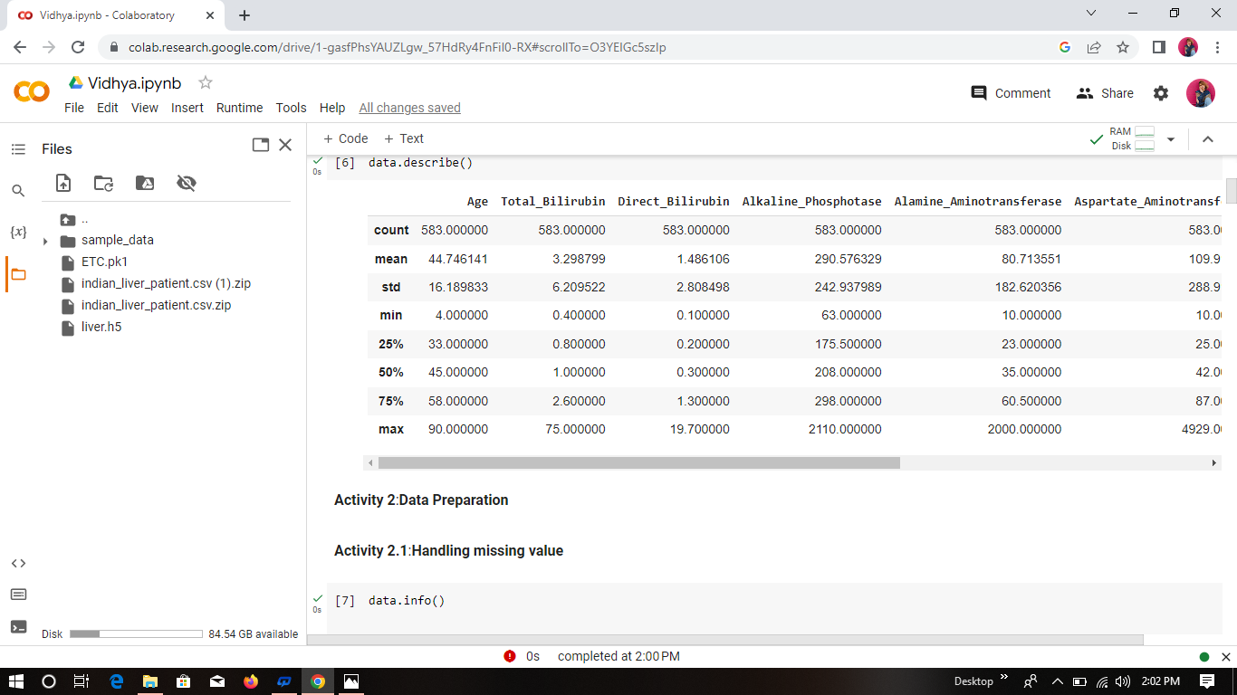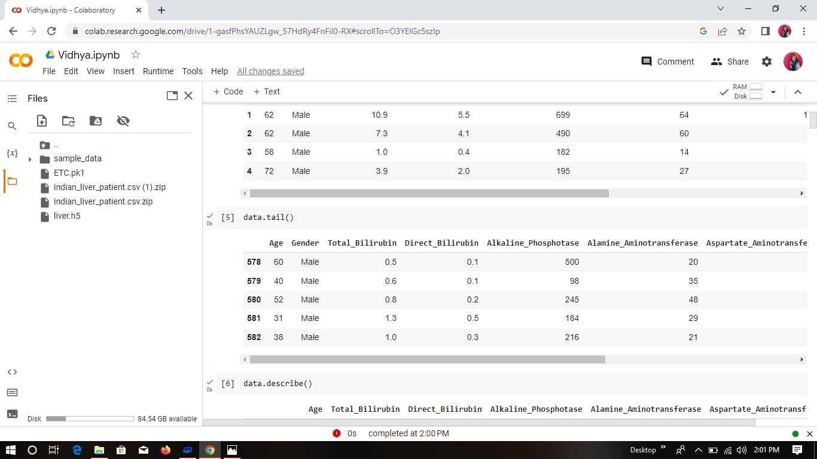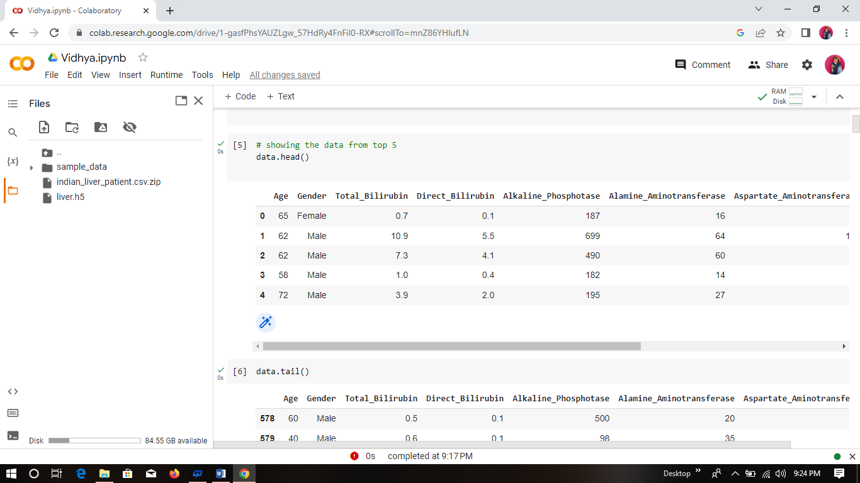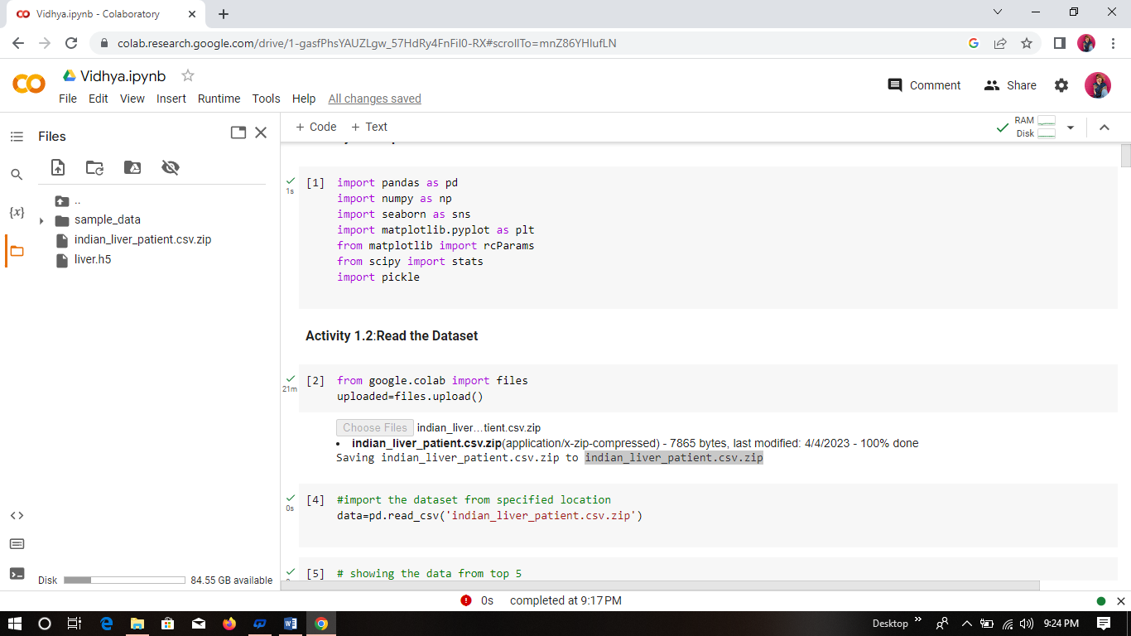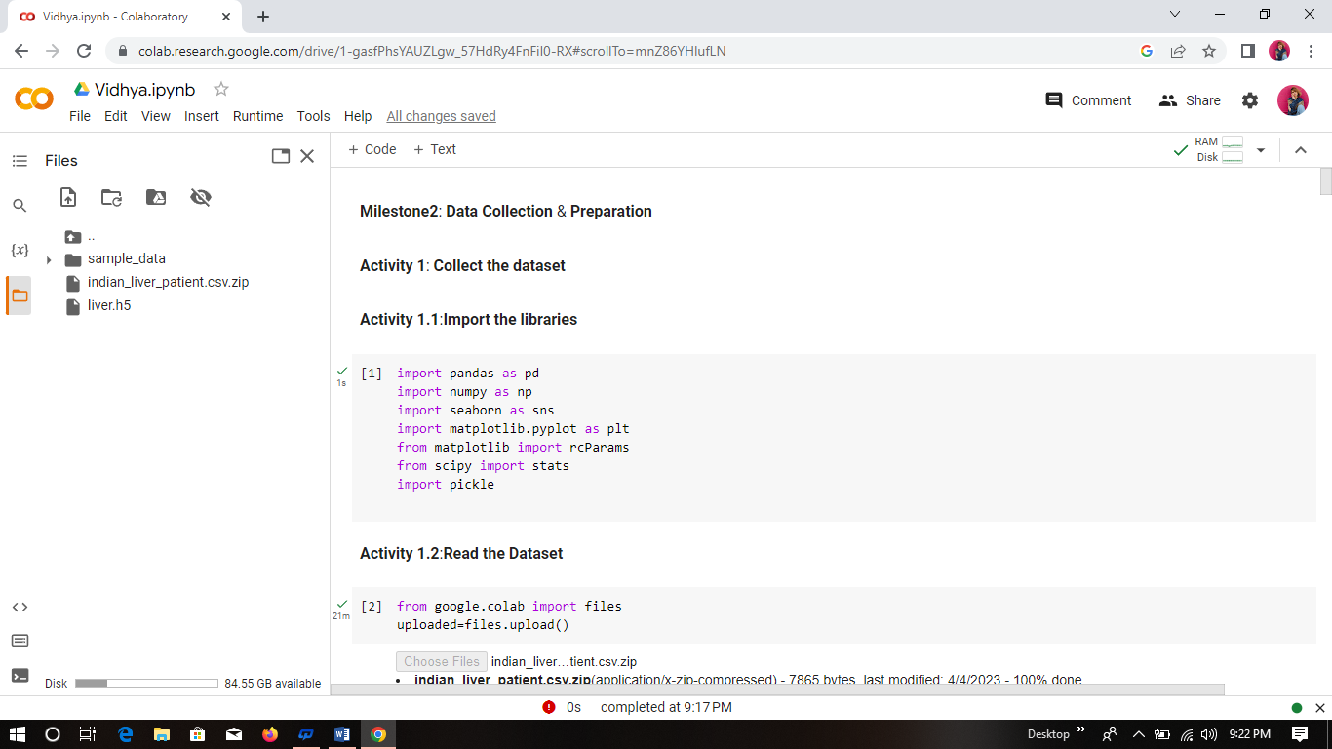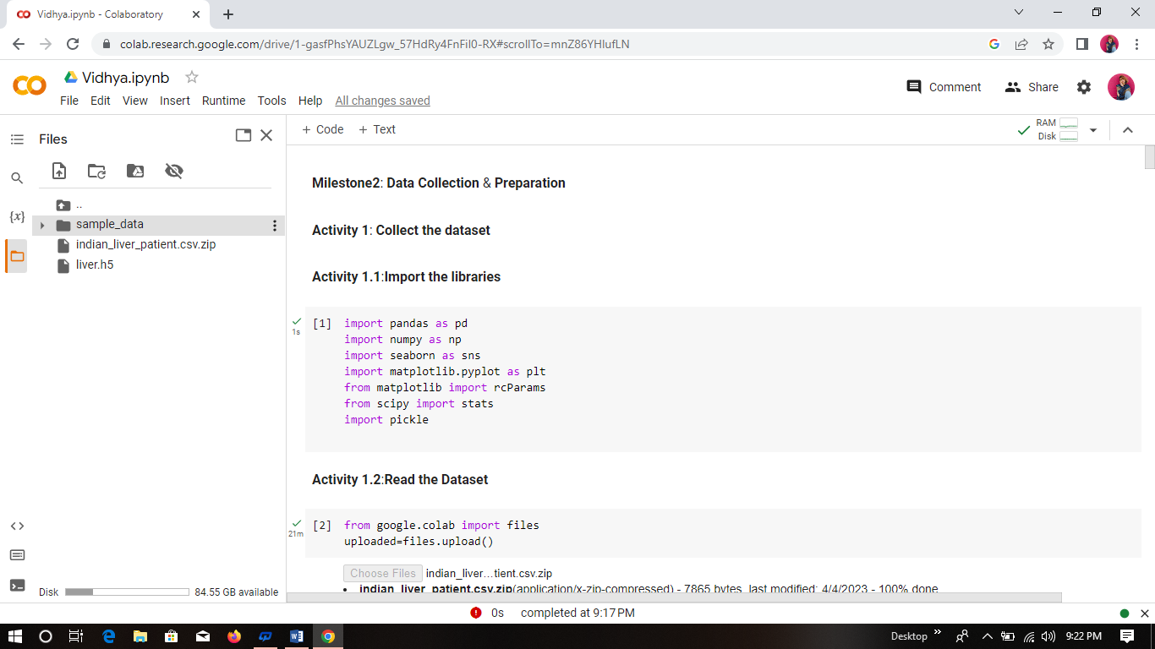

PROBLEM DEFINITION & DESIGN THINKING

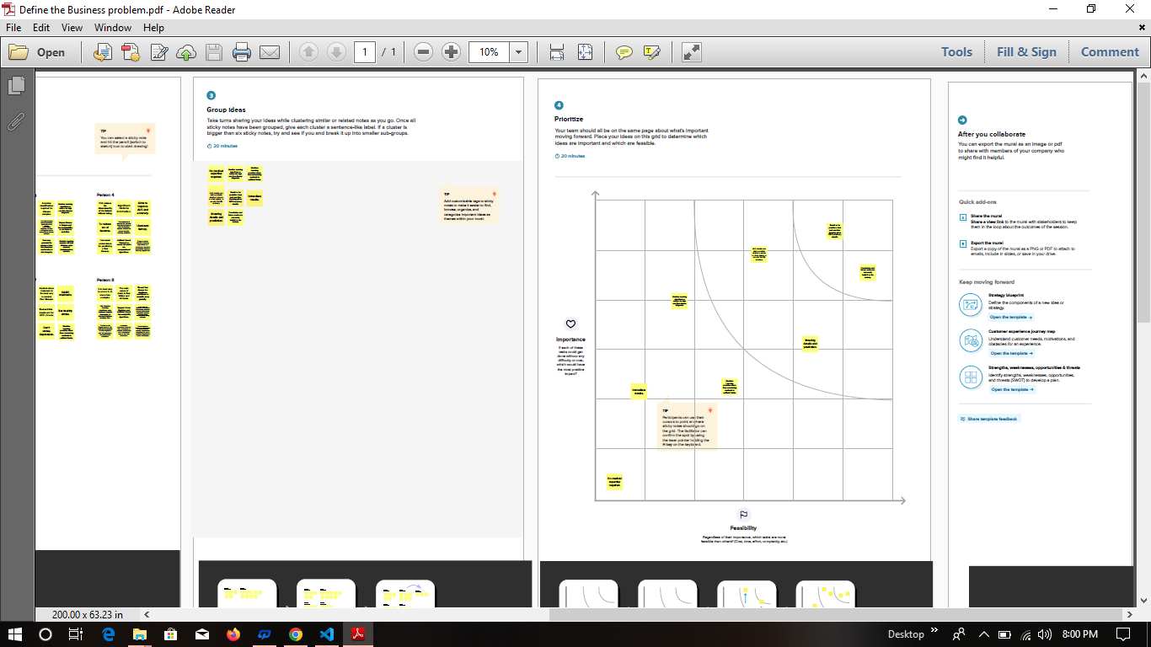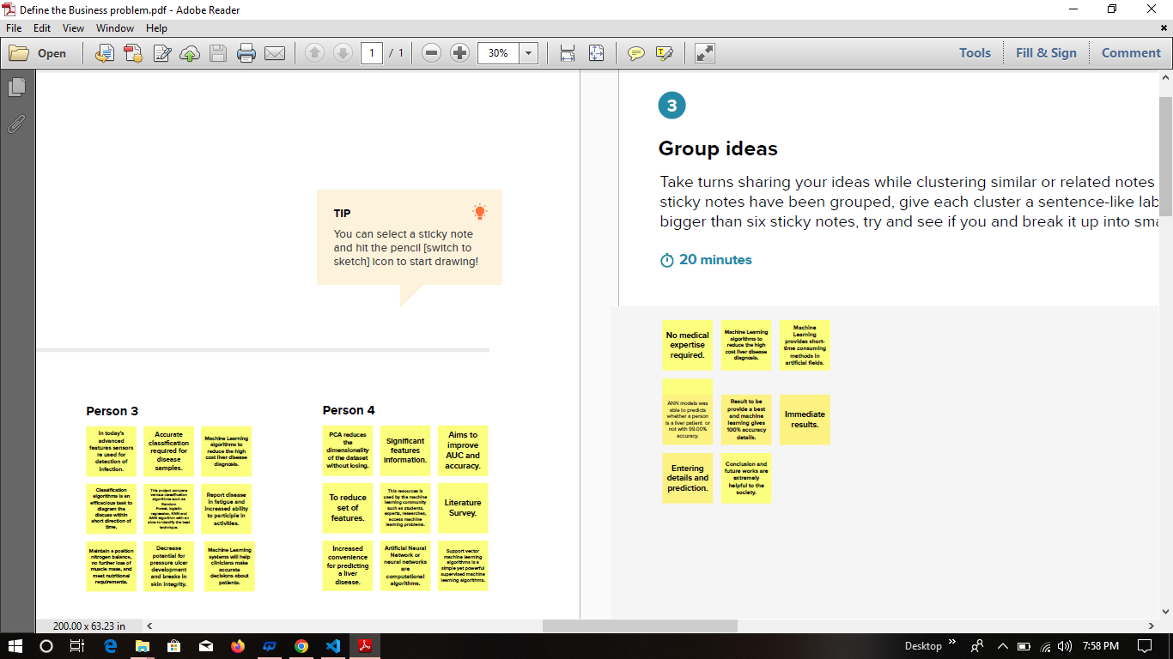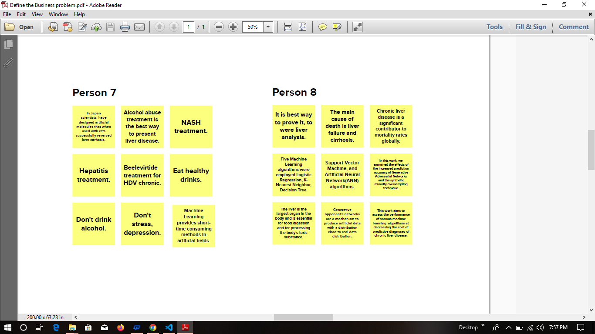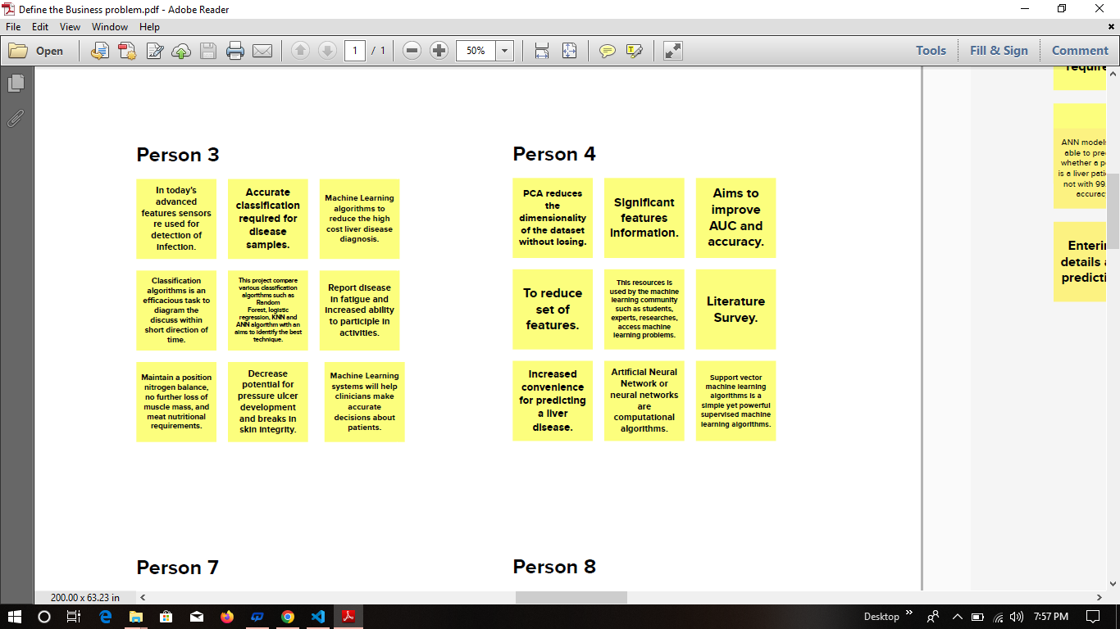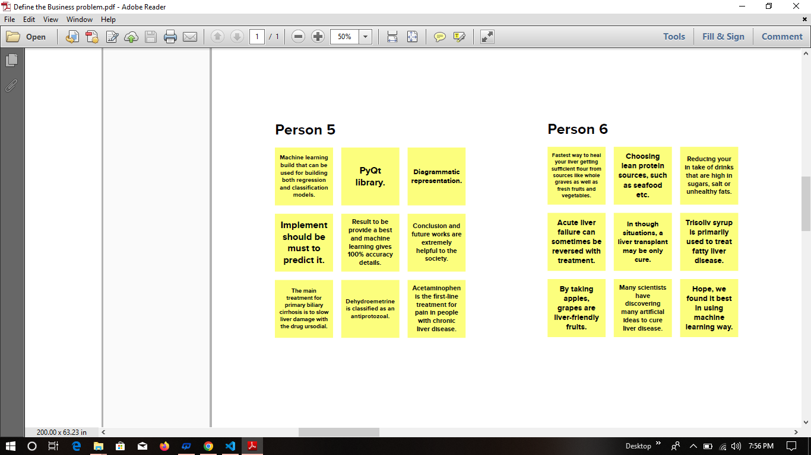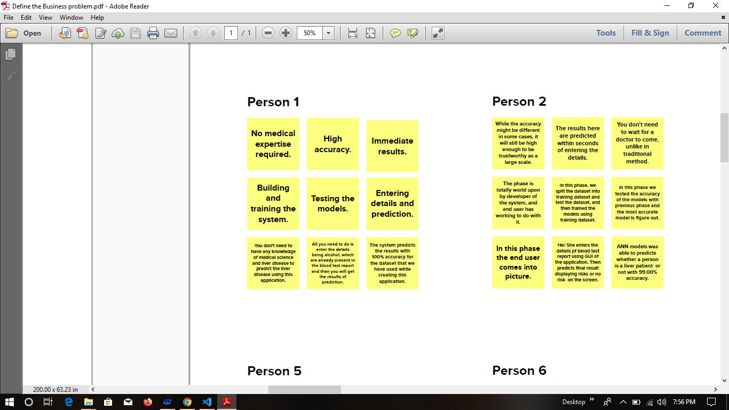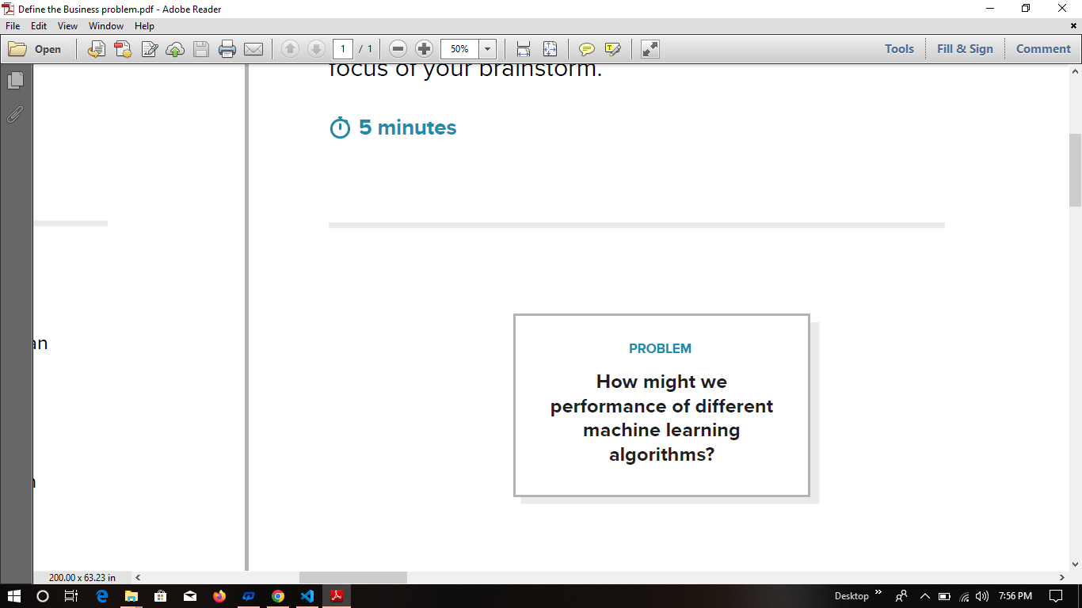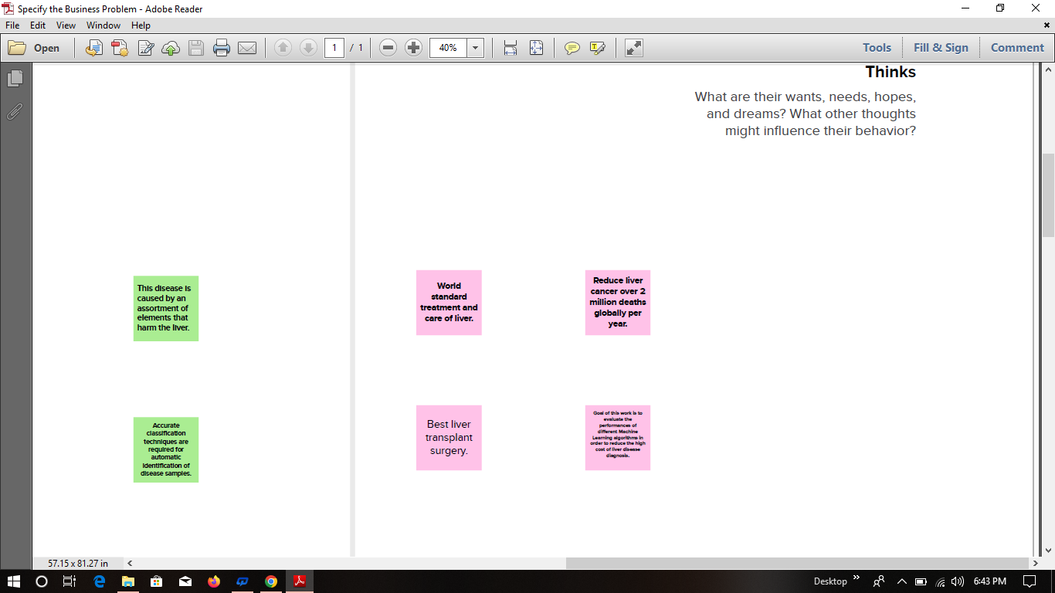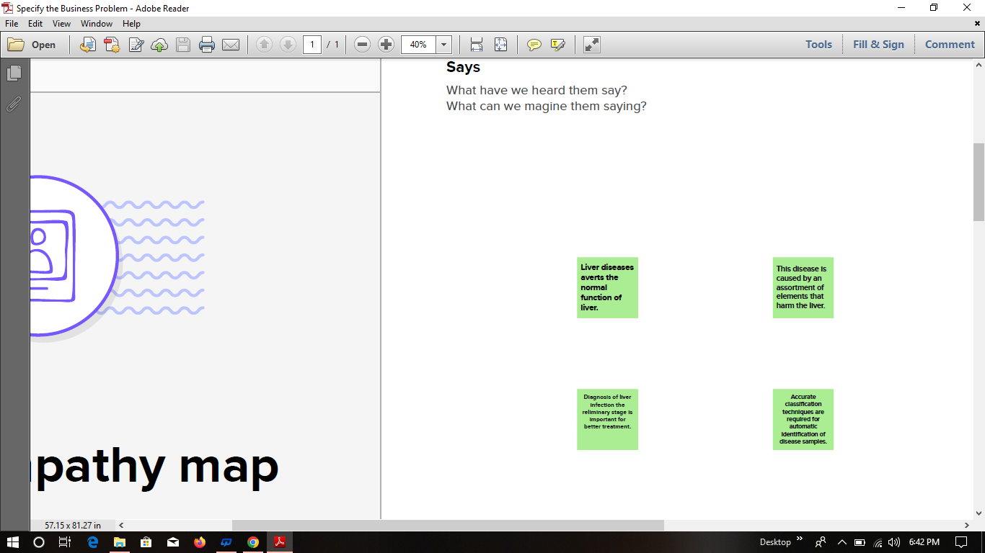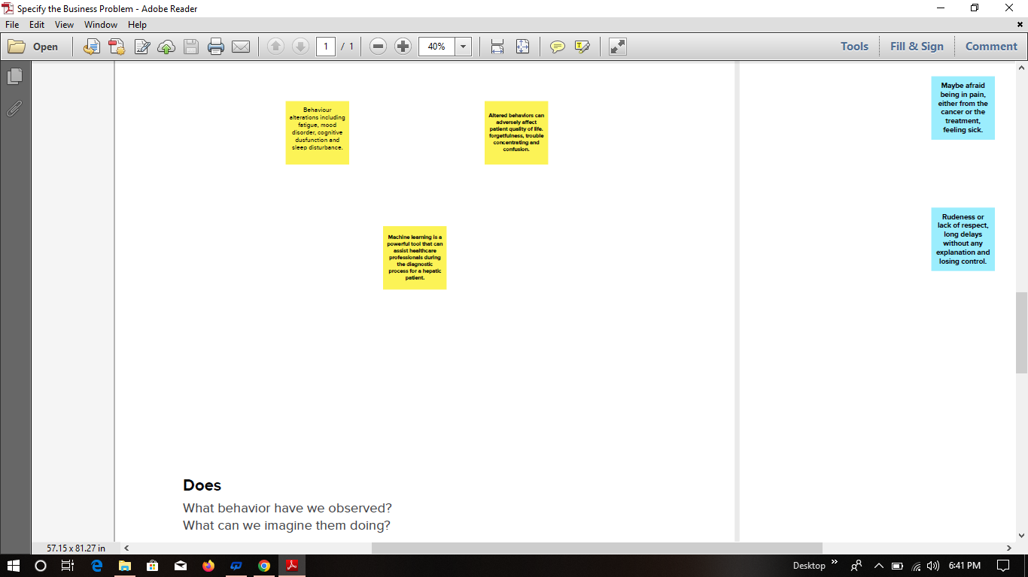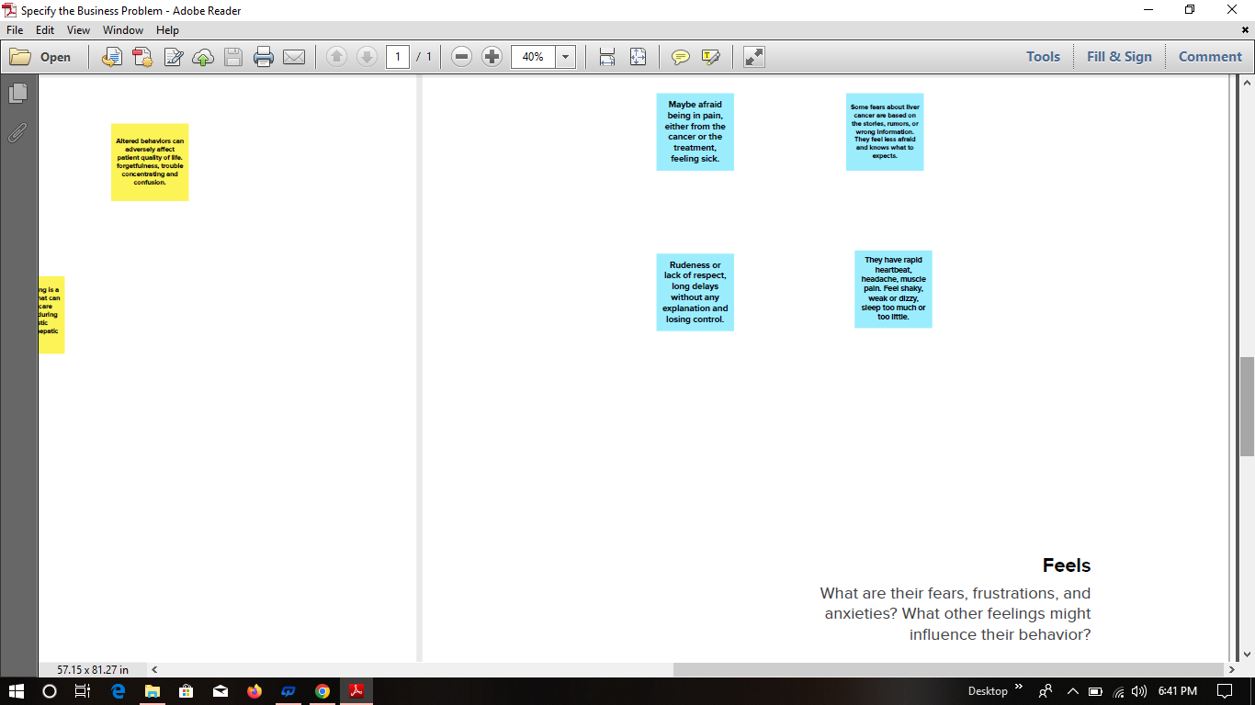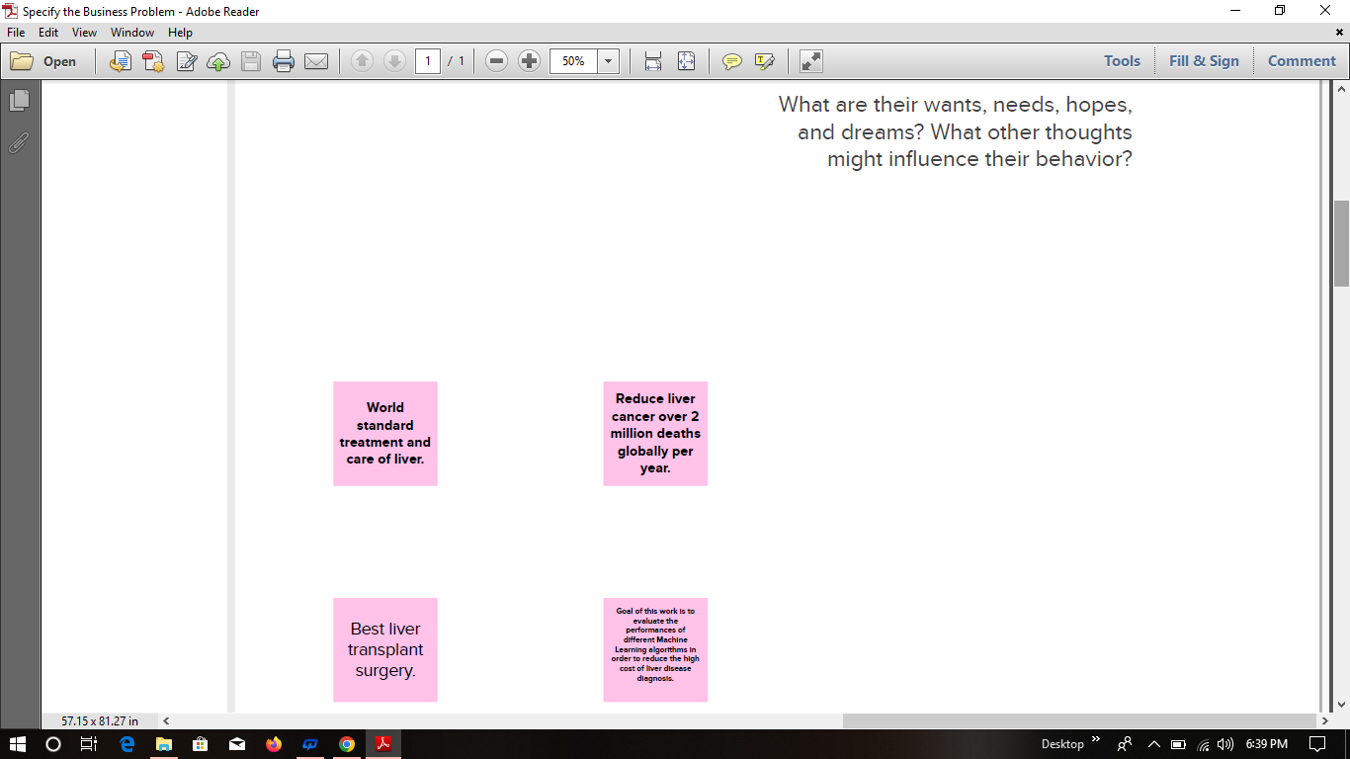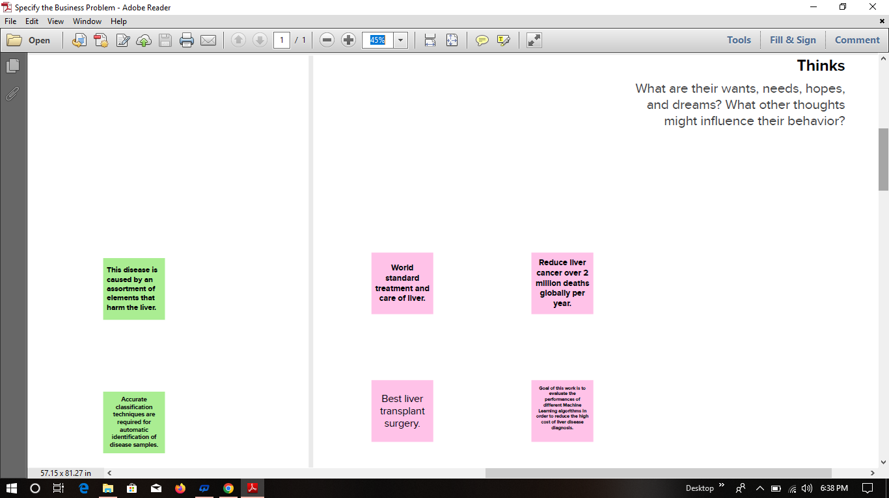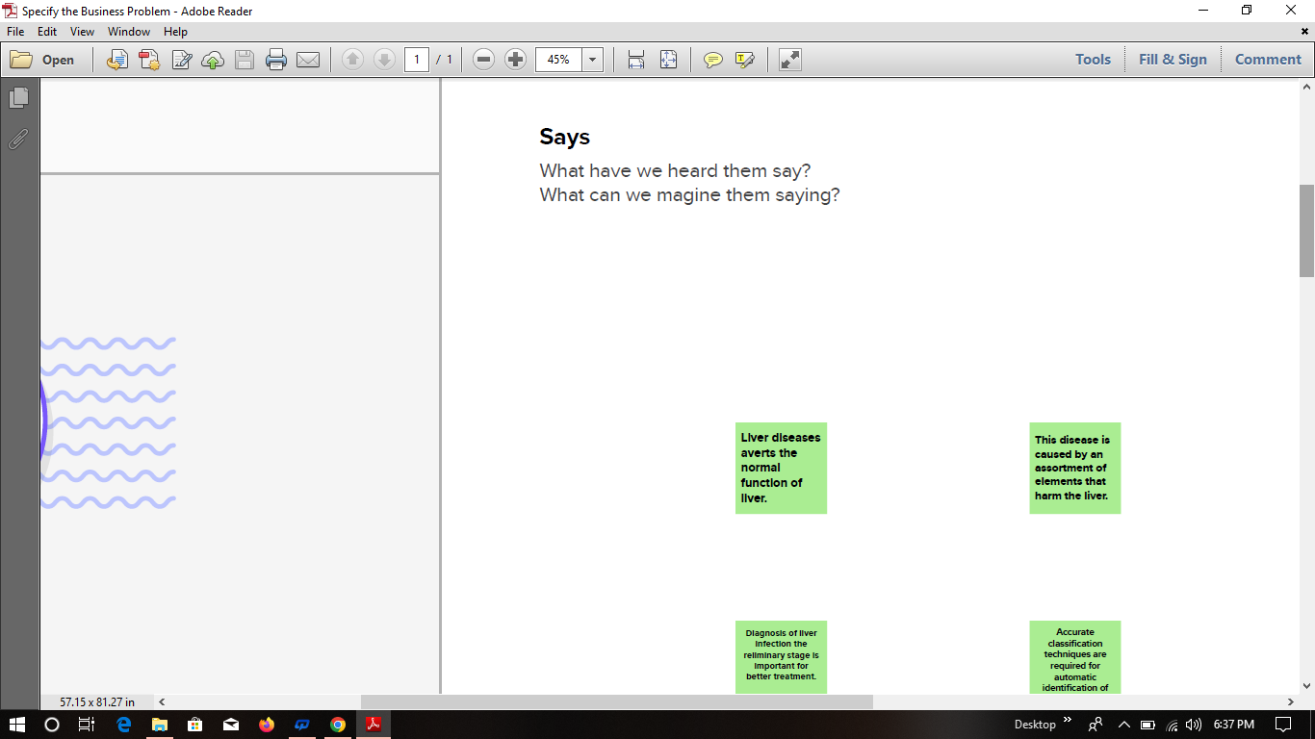

APPENDIX

In [ ]:

In [1]:

**import** pandas **as** pd

**import** numpy **as** np

**import** matplotlib.pyplot **as** plt

**import** seaborn **as** sns

**import** pickle

In [2]:

*#import the dataset from specified location*

data **=** pd**.**read_csv('E:/Datascience/Datasets/indian_liver_patient.csv')

In [3]:

*# showing the data from top 5*

data**.**head()

Out[3]:

|  | **Age** | **Gender** | **Total_Bilirubin** | **Direct_Bilirubin** | **Alkaline_Phosphotase** | **Alamine_Aminotransferase** | **Aspartate_Aminotransferase** | **Total_Protiens** | **Albumin** | **Albumin_and_Globulin_Ratio** | **Dataset** |
| --- | --- | --- | --- | --- | --- | --- | --- | --- | --- | --- | --- |
| **0** | 65 | Female | 0.7 | 0.1 | 187 | 16 | 18 | 6.8 | 3.3 | 0.90 | 1 |
| **1** | 62 | Male | 10.9 | 5.5 | 699 | 64 | 100 | 7.5 | 3.2 | 0.74 | 1 |
| **2** | 62 | Male | 7.3 | 4.1 | 490 | 60 | 68 | 7.0 | 3.3 | 0.89 | 1 |
| **3** | 58 | Male | 1.0 | 0.4 | 182 | 14 | 20 | 6.8 | 3.4 | 1.00 | 1 |
| **4** | 72 | Male | 3.9 | 2.0 | 195 | 27 | 59 | 7.3 | 2.4 | 0.40 | 1 |

In [3]:

data**.**tail()

Out[3]:

|  | **Age** | **Gender** | **Total_Bilirubin** | **Direct_Bilirubin** | **Alkaline_Phosphotase** | **Alamine_Aminotransferase** | **Aspartate_Aminotransferase** | **Total_Protiens** | **Albumin** | **Albumin_and_Globulin_Ratio** | **Dataset** |
| --- | --- | --- | --- | --- | --- | --- | --- | --- | --- | --- | --- |
| **578** | 60 | Male | 0.5 | 0.1 | 500 | 20 | 34 | 5.9 | 1.6 | 0.37 | 2 |
| **579** | 40 | Male | 0.6 | 0.1 | 98 | 35 | 31 | 6.0 | 3.2 | 1.10 | 1 |
| **580** | 52 | Male | 0.8 | 0.2 | 245 | 48 | 49 | 6.4 | 3.2 | 1.00 | 1 |
| **581** | 31 | Male | 1.3 | 0.5 | 184 | 29 | 32 | 6.8 | 3.4 | 1.00 | 1 |
| **582** | 38 | Male | 1.0 | 0.3 | 216 | 21 | 24 | 7.3 | 4.4 | 1.50 | 2 |

In [4]:

data**.**describe()

Out[4]:

|  | **Age** | **Total_Bilirubin** | **Direct_Bilirubin** | **Alkaline_Phosphotase** | **Alamine_Aminotransferase** | **Aspartate_Aminotransferase** | **Total_Protiens** | **Albumin** | **Albumin_and_Globulin_Ratio** | **Dataset** |
| --- | --- | --- | --- | --- | --- | --- | --- | --- | --- | --- |
| **count** | 583.000000 | 583.000000 | 583.000000 | 583.000000 | 583.000000 | 583.000000 | 583.000000 | 583.000000 | 579.000000 | 583.000000 |
| **mean** | 44.746141 | 3.298799 | 1.486106 | 290.576329 | 80.713551 | 109.910806 | 6.483190 | 3.141852 | 0.947064 | 1.286449 |
| **std** | 16.189833 | 6.209522 | 2.808498 | 242.937989 | 182.620356 | 288.918529 | 1.085451 | 0.795519 | 0.319592 | 0.452490 |
| **min** | 4.000000 | 0.400000 | 0.100000 | 63.000000 | 10.000000 | 10.000000 | 2.700000 | 0.900000 | 0.300000 | 1.000000 |
| **25%** | 33.000000 | 0.800000 | 0.200000 | 175.500000 | 23.000000 | 25.000000 | 5.800000 | 2.600000 | 0.700000 | 1.000000 |
| **50%** | 45.000000 | 1.000000 | 0.300000 | 208.000000 | 35.000000 | 42.000000 | 6.600000 | 3.100000 | 0.930000 | 1.000000 |
| **75%** | 58.000000 | 2.600000 | 1.300000 | 298.000000 | 60.500000 | 87.000000 | 7.200000 | 3.800000 | 1.100000 | 2.000000 |
| **max** | 90.000000 | 75.000000 | 19.700000 | 2110.000000 | 2000.000000 | 4929.000000 | 9.600000 | 5.500000 | 2.800000 | 2.000000 |

In [5]:

data**.**info()

<class 'pandas.core.frame.DataFrame'>

RangeIndex: 583 entries, 0 to 582

Data columns (total 11 columns):

# Column Non-Null Count Dtype

--- ------ -------------- -----

0 Age 583 non-null int64

1 Gender 583 non-null object

2 Total_Bilirubin 583 non-null float64

3 Direct_Bilirubin 583 non-null float64

4 Alkaline_Phosphotase 583 non-null int64

5 Alamine_Aminotransferase 583 non-null int64

6 Aspartate_Aminotransferase 583 non-null int64

7 Total_Protiens 583 non-null float64

8 Albumin 583 non-null float64

9 Albumin_and_Globulin_Ratio 579 non-null float64

10 Dataset 583 non-null int64

dtypes: float64(5), int64(5), object(1)

memory usage: 50.2+ KB

In [6]:

data**.**isnull()**.**any()

Out[6]:

Age False

Gender False

Total_Bilirubin False

Direct_Bilirubin False

Alkaline_Phosphotase False

Alamine_Aminotransferase False

Aspartate_Aminotransferase False

Total_Protiens False

Albumin False

Albumin_and_Globulin_Ratio True

Dataset False

dtype: bool

In [7]:

data**.**isnull()**.**sum()

Out[7]:

Age 0

Gender 0

Total_Bilirubin 0

Direct_Bilirubin 0

Alkaline_Phosphotase 0

Alamine_Aminotransferase 0

Aspartate_Aminotransferase 0

Total_Protiens 0

Albumin 0

Albumin_and_Globulin_Ratio 4

Dataset 0

dtype: int64

In [ ]:

In [5]:

data[data['Dataset']**==**1]

Out[5]:

|  | **Age** | **Gender** | **Total_Bilirubin** | **Direct_Bilirubin** | **Alkaline_Phosphotase** | **Alamine_Aminotransferase** | **Aspartate_Aminotransferase** | **Total_Protiens** | **Albumin** | **Albumin_and_Globulin_Ratio** | **Dataset** |
| --- | --- | --- | --- | --- | --- | --- | --- | --- | --- | --- | --- |
| **0** | 65 | Female | 0.7 | 0.1 | 187 | 16 | 18 | 6.8 | 3.3 | 0.90 | 1 |
| **1** | 62 | Male | 10.9 | 5.5 | 699 | 64 | 100 | 7.5 | 3.2 | 0.74 | 1 |
| **2** | 62 | Male | 7.3 | 4.1 | 490 | 60 | 68 | 7.0 | 3.3 | 0.89 | 1 |
| **3** | 58 | Male | 1.0 | 0.4 | 182 | 14 | 20 | 6.8 | 3.4 | 1.00 | 1 |
| **4** | 72 | Male | 3.9 | 2.0 | 195 | 27 | 59 | 7.3 | 2.4 | 0.40 | 1 |
| **...** | ... | ... | ... | ... | ... | ... | ... | ... | ... | ... | ... |
| **576** | 32 | Male | 15.0 | 8.2 | 289 | 58 | 80 | 5.3 | 2.2 | 0.70 | 1 |
| **577** | 32 | Male | 12.7 | 8.4 | 190 | 28 | 47 | 5.4 | 2.6 | 0.90 | 1 |
| **579** | 40 | Male | 0.6 | 0.1 | 98 | 35 | 31 | 6.0 | 3.2 | 1.10 | 1 |
| **580** | 52 | Male | 0.8 | 0.2 | 245 | 48 | 49 | 6.4 | 3.2 | 1.00 | 1 |
| **581** | 31 | Male | 1.3 | 0.5 | 184 | 29 | 32 | 6.8 | 3.4 | 1.00 | 1 |

416 rows × 11 columns

In [107]:

data['Dataset']**.**unique()

Out[107]:

array([1, 2], dtype=int64)

In [108]:

*#checking for missing data*

data**.**isnull()**.**sum()

Out[108]:

Age 0

Gender 0

Total_Bilirubin 0

Direct_Bilirubin 0

Alkaline_Phosphotase 0

Alamine_Aminotransferase 0

Aspartate_Aminotransferase 0

Total_Protiens 0

Albumin 0

Albumin_and_Globulin_Ratio 4

Dataset 0

dtype: int64

In [5]:

data['Albumin_and_Globulin_Ratio'] **=** data**.**fillna(data['Albumin_and_Globulin_Ratio']**.**mode()[0])

In [110]:

*#checking for the missing data after cleaning data*

data['Albumin_and_Globulin_Ratio'] **=** data**.**fillna(data['Albumin_and_Globulin_Ratio']**.**mode()[0])

data**.**isnull()**.**sum()

Out[110]:

Age 0

Gender 0

Total_Bilirubin 0

Direct_Bilirubin 0

Alkaline_Phosphotase 0

Alamine_Aminotransferase 0

Aspartate_Aminotransferase 0

Total_Protiens 0

Albumin 0

Albumin_and_Globulin_Ratio 0

Dataset 0

dtype: int64

In [ ]:

In [111]:

plt**.**figure(figsize**=**(15,10))

plt**.**subplot(3,3,1)

plt**.**scatter(data['Age'], data['Dataset'])

ylabel('Dataset')

xlabel('Age')

plt**.**subplot(3,3,2)

plt**.**scatter(data['Gender'], data['Dataset'],)

ylabel('Dataset')

xlabel('Gender')

plt**.**subplot(3,3,3)

plt**.**scatter(data['Total_Bilirubin'], data['Dataset'],)

ylabel('Dataset')

xlabel('Total_Bilirubin')

plt**.**subplot(3,3,4)

plt**.**scatter(data['Direct_Bilirubin'], data['Dataset'],)

ylabel('Dataset')

xlabel('Direct_Bilirubin')

plt**.**subplot(3,3,5)

plt**.**scatter(data['Alkaline_Phosphotase'], data['Dataset'],)

ylabel('Dataset')

xlabel('Alkaline_Phosphotase')

plt**.**subplot(3,3,6)

plt**.**scatter(data['Alamine_Aminotransferase'], data['Dataset'],)

ylabel('Dataset')

xlabel('Alamine_Aminotransferase')

plt**.**subplot(3,3,7)

plt**.**scatter(data['Aspartate_Aminotransferase'], data['Dataset'],)

ylabel('Dataset')

xlabel('Aspartate_Aminotransferase')

plt**.**subplot(3,3,8)

plt**.**scatter(data['Total_Protiens'], data['Dataset'],)

ylabel('Dataset')

xlabel('Total_Protiens')

plt**.**subplot(3,3,9)

plt**.**scatter(data['Albumin_and_Globulin_Ratio'], data['Dataset'])

ylabel('Dataset')

xlabel('Albumin_and_Globulin_Ratio')

Out[111]:

Text(0.5, 0, 'Albumin_and_Globulin_Ratio')

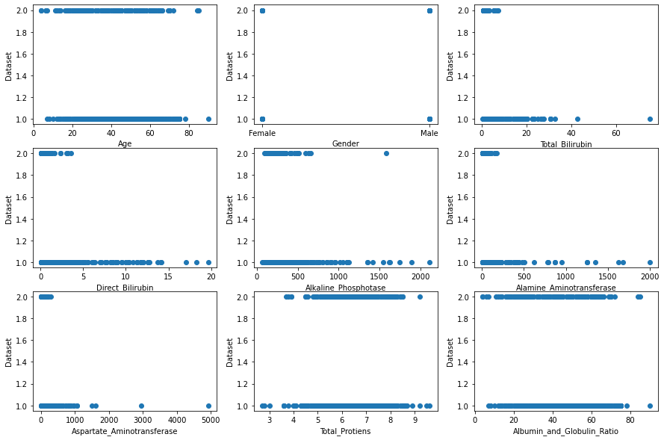In [175]:

*# Counting patients who are diagnosed and not diagnoised with liver disease*

sns**.**countplot(data**=**data, x **=** 'Dataset')

LD,NLD**=**data['Dataset']**.**value_counts()

print("liver disease patinets:",LD)

print("Non-liver disease patinets:",NLD)

liver disease patinets: 416

Non-liver disease patinets: 167

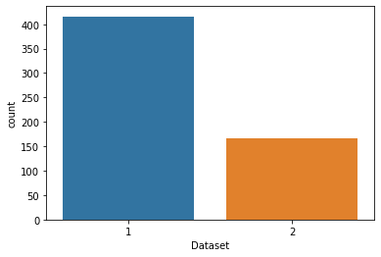In [173]:

*# Counting patients who are Male and who are Female*

sns**.**countplot(data**=**data, x **=** 'Gender', label**=**'Count')

m,f**=**data['Gender']**.**value_counts()

print("No of Males:",m)

print("No of Females:",f)

No of Males: 441

No of Females: 142

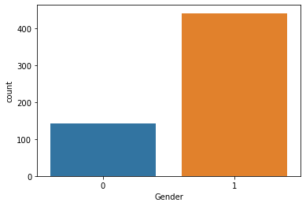In [8]:

*# Importing the LabelEncoder libraray from scikit-learn*

**from** sklearn.preprocessing **import** LabelEncoder

le**=**LabelEncoder()

*# Converting Textual data into numeric data*

data['Gender'] **=** le**.**fit_transform(data['Gender'])

data**.**head()

Out[8]:

|  | **Age** | **Gender** | **Total_Bilirubin** | **Direct_Bilirubin** | **Alkaline_Phosphotase** | **Alamine_Aminotransferase** | **Aspartate_Aminotransferase** | **Total_Protiens** | **Albumin** | **Albumin_and_Globulin_Ratio** | **Dataset** |
| --- | --- | --- | --- | --- | --- | --- | --- | --- | --- | --- | --- |
| **0** | 65 | 0 | 0.7 | 0.1 | 187 | 16 | 18 | 6.8 | 3.3 | 0.90 | 1 |
| **1** | 62 | 1 | 10.9 | 5.5 | 699 | 64 | 100 | 7.5 | 3.2 | 0.74 | 1 |
| **2** | 62 | 1 | 7.3 | 4.1 | 490 | 60 | 68 | 7.0 | 3.3 | 0.89 | 1 |
| **3** | 58 | 1 | 1.0 | 0.4 | 182 | 14 | 20 | 6.8 | 3.4 | 1.00 | 1 |
| **4** | 72 | 1 | 3.9 | 2.0 | 195 | 27 | 59 | 7.3 | 2.4 | 0.40 | 1 |

In [177]:

*#Converting Textual data into numeric data*

data['Gender'] **=** le**.**fit_transform(data['Gender'])

In [178]:

data**.**head()

Out[178]:

|  | **Age** | **Gender** | **Total_Bilirubin** | **Direct_Bilirubin** | **Alkaline_Phosphotase** | **Alamine_Aminotransferase** | **Aspartate_Aminotransferase** | **Total_Protiens** | **Albumin** | **Albumin_and_Globulin_Ratio** | **Dataset** |
| --- | --- | --- | --- | --- | --- | --- | --- | --- | --- | --- | --- |
| **0** | 65 | 0 | 0.7 | 0.1 | 187 | 16 | 18 | 6.8 | 3.3 | 65 | 1 |
| **1** | 62 | 1 | 10.9 | 5.5 | 699 | 64 | 100 | 7.5 | 3.2 | 62 | 1 |
| **2** | 62 | 1 | 7.3 | 4.1 | 490 | 60 | 68 | 7.0 | 3.3 | 62 | 1 |
| **3** | 58 | 1 | 1.0 | 0.4 | 182 | 14 | 20 | 6.8 | 3.4 | 58 | 1 |
| **4** | 72 | 1 | 3.9 | 2.0 | 195 | 27 | 59 | 7.3 | 2.4 | 72 | 1 |

In [186]:

x**=**data**.**iloc[:,0:**-**1]

y**=**data**.**iloc[:,**-**1]

In [9]:

*# dividing the data into input and output*

x**=**data**.**iloc[:,0:**-**1]

y**=**data**.**iloc[:,**-**1]

In [10]:

*# importing the train_test_split from scikit-learn*

**from** sklearn.model_selection **import** train_test_split

xtrain,xtest,ytrain,ytest**=**train_test_split(x,y,test_size**=**0.2)

In [12]:

*# Returns size of xtrain*

xtrain**.**shape

Out[12]:

(466, 10)

In [14]:

*# Returns size of xtest*

xtest**.**shape

Out[14]:

(117, 10)

In [ ]:

**from** sklearn.metrics **import** accuracy_score

**from** sklearn.metrics **import** confusion_matrix

In [ ]:

In [ ]:

*# Importing the machine learning model*

**from** sklearn.svm **import** SVC

**from** sklearn.ensemble **import** RandomForestClassifier

**from** sklearn.neighbors **import** KNeighborsClassifier

In [ ]:

*# Initializing the machine learning models*

svm**=**SVC()

RFmodel**=**RandomForestClassifier()

KNNmodel**=**KNeighborsClassifier()

In [ ]:

In [208]:

*#Support Vector Machine Model*

**from** sklearn.svm **import** SVC

svm**=**SVC()

In [209]:

*# train the data with SVM model*

svm**.**fit(xtrain, ytrain)

Out[209]:

SVC()

In [210]:

SVMpred**=**svm**.**predict(xtest)

In [233]:

*# Checking for accuracy score from actual data and predicted data*

SVMaccuracy**=**accuracy_score(SVMpred, ytest)

SVMaccuracy

Out[233]:

0.7606837606837606

In [235]:

*# showing the confusion matrix*

SVMcm**=**confusion_matrix(SVMpred, ytest)

SVMcm

Out[235]:

array([[89, 28],

[ 0, 0]], dtype=int64)

In [ ]:

In [213]:

*#Random Forest Classifier Model*

**from** sklearn.ensemble **import** RandomForestClassifier

RFmodel**=**RandomForestClassifier()

In [214]:

*# train the data with Random Forest model*

RFmodel**.**fit(xtrain, ytrain)

Out[214]:

RandomForestClassifier()

In [215]:

RFpred**=**RFmodel**.**predict(xtest)

In [237]:

*# Checking for accuracy score from actual data and predicted data*

RFaccuracy**=**accuracy_score(RFpred, ytest)

RFaccuracy

Out[237]:

0.7094017094017094

In [239]:

*# showing the confusion matrix*

RFcm**=**confusion_matrix(RFpred, ytest)

RFcm

Out[239]:

array([[77, 22],

[12, 6]], dtype=int64)

In [ ]:

In [ ]:

In [218]:

*# K-Nearest Neighbors Model*

**from** sklearn.neighbors **import** KNeighborsClassifier

KNN **=** KNeighborsClassifier()

In [219]:

*# train the data with K-Nearest Neighbors Model*

KNN**.**fit(xtrain, ytrain)

Out[219]:

KNeighborsClassifier()

In [221]:

KNNpred**=**KNN**.**predict(xtest)

In [241]:

*# Checking for accuracy score from actual data and predicted data*

KNNaccuracy**=**accuracy_score(KNNpred, ytest)

KNNaccuracy

Out[241]:

0.6495726495726496

In [243]:

*# showing the confusion matrix*

KNNcm**=**confusion_matrix(KNNpred, ytest)

KNNcm

Out[243]:

array([[70, 22],

[19, 6]], dtype=int64)

print("Support Vector Machine Algorithm accuracy score : {value:.2f} %"**.**format(value**=**SVMaccuracy**\***100))

print("Random Forest Algorithm accuracy score : {value:.2f} %"**.**format(value**=**RFaccuracy**\***100))

print("K-Nearest Neighbors Algorithm accuracy score : {value:.2f} %"**.**format(value**=**KNNaccuracy**\***100))

Support Vector Machine Algorithm accuracy score : 76.07 %

Random Forest Algorithm accuracy score : 70.94 %

K-Nearest Neighbors Algorithm accuracy score : 64.96 %

*# saving the model*

**import** pickle

pickle**.**dump(svm, open('liver_analysis.pkl','wb'))